

**<<BMOS>>**

**Bird Meal Order System**

– HoChiMinh, May 2023 –

**Group 5 - Bird Meals Order System**

* Nguyễn Tấn Đạt - SE161864
* Lê Chí Phát - SE161865
* Phan Văn Cường - SE161850
* Nguyễn Đoàn Anh Duy - SE161859
* Phạm Võ Minh Tâm - SE161816

**PROCESS FEATURE:**[**Process Feature - BMOS - Google Trang tính**](https://docs.google.com/spreadsheets/d/1DTs_g6HtSjsNskK-KXeCrVk-5Jq9lABQUq1GII-uTXw/edit?hl=vi#gid=0)

**Table of Contents**

**I. Overview 4**

1. Introduction 4

2. System Functions 6

a. Screen Flow 6

b. Screen Details 6

c. User Authorization 8

d. Non-Screen Functions 9

3. Entity Relationship Diagram 9

**II. Functional Requirements 10**

*Public Feature 10

1. Home Page 10

2. Login 10

3. Register. 11

4. Forgot Password 12

5. Web Product List 13

6. Web Product Detail 13

7. Web Meal Routing List 14

8. Web Meal Routing Detail 15

9. Web Blog List 16

10. Web Blog Detail 17

11. Search Product/Meal Routing 18

*Common Feature 19

1. View User Profile 19

2. Edit User Profile 19

3. Change Password 20

4. Log out 21

*Admin Feature 21

1. Dashboard 21

2. Manage Account 22

a. View Account List 22

b. View Account Detail 22

c. Edit Account 23

d. Block Account 24

e. Search Account 25

f. Add Account With Role Staff 25

*Staff Feature 26

1. Manage Product 26

a. View Product List 26

b. View Product Detail 27

c. Search Product 27

d. Add New Product 28

e. Edit Product 29

f. Remove Product 29

2. Manage Meal Routing 30

a. View Meal Routing List 30

b. View Meal Routing Detail 30

d. Add New Meal Routing 31

e. Edit Meal Routing 32

f. Remove Meal Routing 33

3. Manage Order 33

a. View Order List 33

b. View Order Detail 33

4. Manage Blog 34

a.Add Blog 34

b.Edit Blog 35

5. Manage Feedback 36

a. View Feedback List 36

b. View Feedback Detail 37

c. Delete Feedback 37

6. Manage Refund 38

C. View Refund Detail 39

*Customer Feature 40

1. Cart 40

a. Add Product To Cart 40

b. Edit Product In Cart 41

c. Cart Detail 42

d. Use Point And Voucher 43

2. Feedback 43

a. Add Product To Favourite List 43

b. View Product In Favourite List 44

c. Remove Product From Favourite List 45

d. Rating Product 45

e. View Feedback 45

f. Send Feedback 46

3. Checkout 47

4. Contact 47

5. Get Point Bonus 48

6. User Profile 49

a. Add User Location 49

b. Edit User Location 50

c. View Order History 50

d. Refund Order 51

# 

# 

# 

# 

# I. Overview

## 1. Introduction

Our product is an online shopping platform on the website designed to give customers a shopping experience for their pet bird food. It will allow customers to find and choose the right food for each type of bird, with a certain origin, and we provide a variety of feeding routes for a variety of improvement purposes. Thereby helping bird owners to care about the quality of meals for their pets.

The platform will be used in a consumer setting, accessed through a web browser. Customers will require an internet connection to use the platform. The platform will depend on third-party services, such as Momo payment gateways and shipping providers, to function properly.

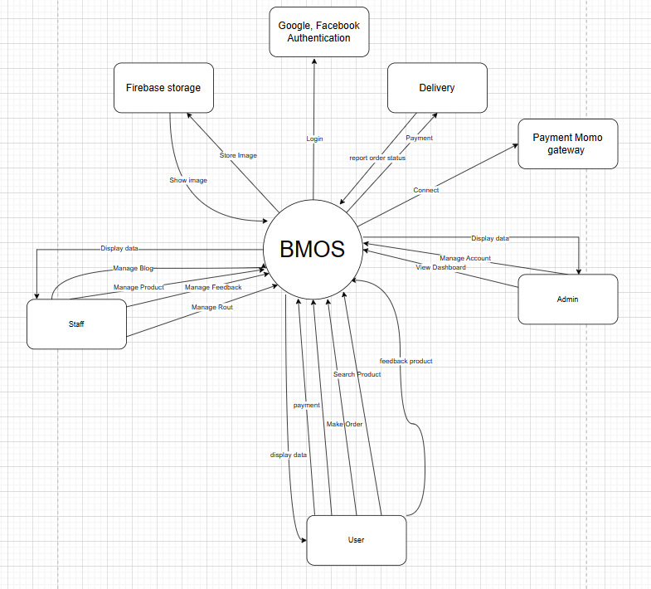

## 2. System Functions

### a. Screen Flow

*[This part shows the system screens and the relationship among screens. You can draw the Screens Flow for the system in the form of diagram as below]*

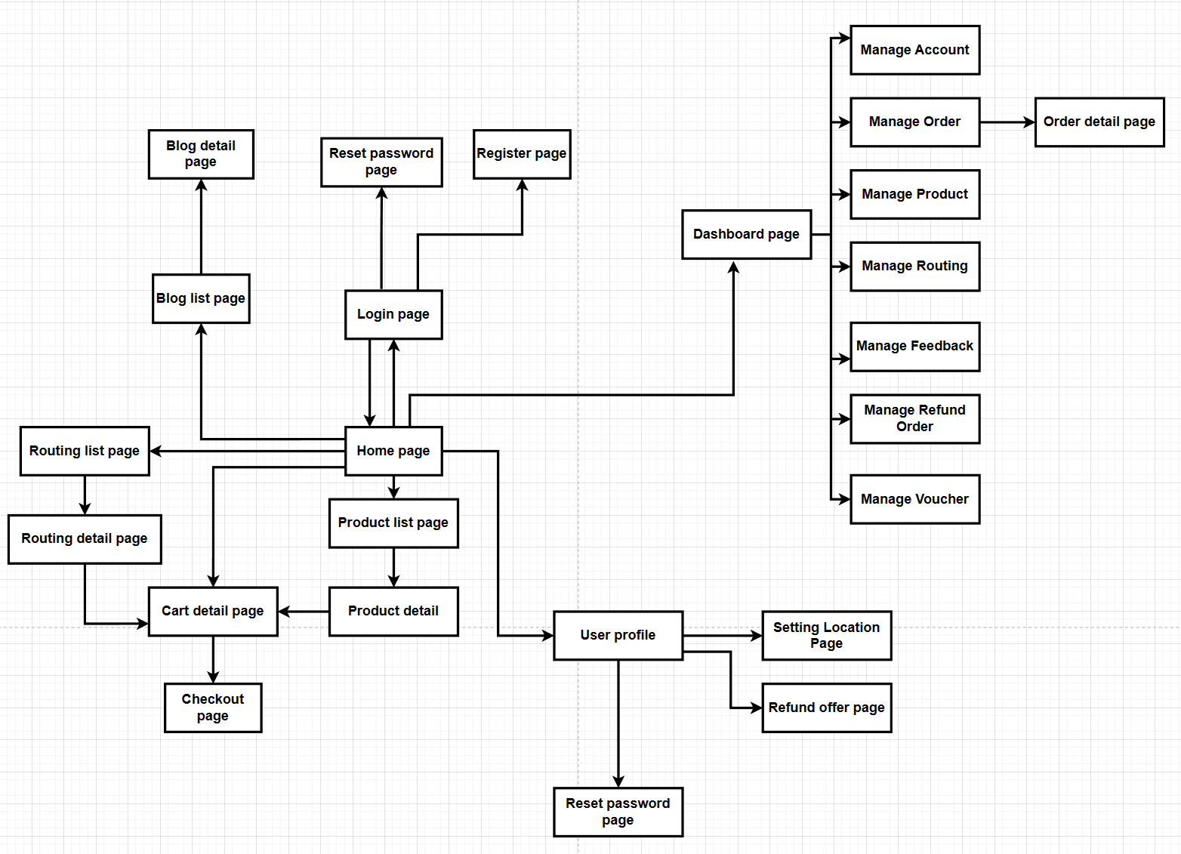

### b. Screen Details

*[Provide the descriptions for the screens in the Screens Flow above]*

| **Code** | **Feature function** | **Screen** | **Description** |
| --- | --- | --- | --- |
| B001 | Login | User Login | Has a form field username and password to login or you can login with Gmail or Facebook. |
| B002 | Reset password | If you forgot the password please choose the reset button. |
| B003 | Register | User Register | Have a form for new users to fill in username and password. |
| B004 | Logout | User Profile | Has a logout button to log out current users. |
| B005 | Change password | User Profile | Has a change password option so users can change their password. |
| B006 | Edit profile | Render a form with info user files such as: input user name, user email…. for user can fill in. |
| B007 | Search with filter | Home page | Has a form, or radius form for customers to type what they want to filter in search to buy in the product list. |
| B008 | Search with filter | Product List | The same feature but in another screen. |
| B008 | Search with filter | Product Detail | The same feature but in another screen. |
| B010 | Search with filter | Checkout | The same feature but in another screen. |
| B011 | Search with no filter | Product Detail | The same feature but in another screen. |
| B012 | Search with no filter | Home page | Customers can search all product lists in search type input. |
| B013 | Search with no filter | Product List | The same feature but in another screen. |
| B014 | Search with no filter | Checkout | The same feature but in another screen. |
| B015 | View product list/meal routing | Home page | The system will render the product and meal routing list when they visit the homepage.. |
| B016 | View Products/Meal routing Detail | Product/Meal Details | This page shows detailed information of products or meal routing that the user wants to see. |
| B017 | Rating | Product Detail | Display one to five stars for customers to choose which start they want to rate. |
| B018 | View feedback | Display product feedback of other customers when staff commit. |
| B019 | Send feedback | Have a textbox under product detail for customers to type their feedback. |
| B020 | Add product to cart | Have a button to add product in cart and notify for customer quantity of product in cart. |
| B021 | Add favourite product | Have an icon heart to add products to customer favourite lists. |
| B022 | View favourite list | Favourite Page | Show all customers favourite products. |
| B023 | Edit products to cart | Cart Detail | In this page, user can edit increase or decrease the number of products added to cart |
| B024 | Use point | Users can use their accumulated points to reduce the price of their orders. |
| B025 | Use voucher | Users can voucher to reduce the price of their order. |
| View total price | User can view total price of products added to cart |
| View total price | Checkout | User can see the total amount of his order needed to pay. |
| Choose payment type | Users can choose to pay via COD or via Momo. |
| B027 | Contact | All pages except management page | Users can contact staff by Zalo or Facebook. |
| B028 |
| B030 |
| B031 |
| B032 | Add Product to cart | Home Page | Add 1 product to the cart when the user clicks on the cart icon. |
| B033 | Dashboard | Management Page | View report revenue of shop |
| B034 | View Account List | Show list account of system include staff and customer account |
| B035 | View Account Profile | View account profile |
| B036 | Edit Account Profile | Can change profile information and disable accounts. |
| B037 | Filter Account | Can filter customer account and customer account |
| B038 | Add Product | Create new product in system |
| B039 | Add Meal Routing | Create new meal routing in system |
| B040 | Edit Meal Routing | Edit meal routing detail or remove them |
| B041 | Edit Blog | Edit blog detail or remove them |
| B042 | Create Blog | Post a blog on a blog page. |
| B043 | View Order | Displays all list orders that have been checked out by the user. |
| B044 | View Feedback | Show all user reviews of products they have purchased. |
| B045 | Remove Feedback | Staff can remove inappropriate reviews. |
| B046 | View Refund | Displays all order refunds after the user fills in the refund form. |
| B047 | Edit Refund | The staff can view the refund order information and make a decision to accept or deny the refund. |
| B048 | View Voucher | Displays all vouchers and their usage voucher. |
| B049 | Create Voucher | Staff can add a new voucher and the number of times that voucher is used. |
| B050 | View Blog List | Home Page | Show all blog for customers choose when staff commit |
| B051 | View Blog Detail | Blog Detail Page | This page displays all the information that the customer's blog chooses |

### 

### c. User Authorization

*[Provide the system roles authorization to the system features (down to screens, and event to the screen activities if applicable) in the table form as below – replace Role1, Role2,… with the specific system user role names]*

| **Screen** | **Admin** | **Staff** | **Customer** | **Guest** |
| --- | --- | --- | --- | --- |
| Login Page | X | X | X | X |
| Home Page |  | X | X | X |
| Register Page |  |  | X | X |
| Reset Password Page | X |  | X | X |
| User Profile Page | X |  | X |  |
| Setting Location Page |  |  | X |  |
| Order History Page |  |  | X |  |
| Refund Order Page |  |  | X |  |
| Contact Page |  |  | X |  |
| Products List Page |  | X | X | X |
| Products Detail Page |  | X | X | X |
| Routing List Page |  | X | X | X |
| Routing Detail Page |  | X | X | X |
| Blog Page |  | X | X | X |
| Blog Detail Page |  | X | X | X |
| Cart Detail Page |  |  | X |  |
| Checkout Page |  |  | X |  |
| Management Page | X | X |  |  |
| Dashboard Page | X |  |  |  |
| Account Management Page | X |  |  |  |
| Order Management Page |  | X |  |  |
| Product Management Page |  | X |  |  |
| Feedback Management Page |  | X |  |  |
| Contact Management Page |  | X |  |  |
| Blog Management Page |  | X |  |  |
| Routing Management Page |  | X |  |  |
| Voucher Management Page |  | X |  |  |
| Refund Management Page |  | X |  |  |

### d. Non-Screen Functions

*[Provide the descriptions for the non-screen system functions, i.e batch/cron job, service, API, etc.]*

| **#** | **Feature** | **System Function** | **Description** |
| --- | --- | --- | --- |
| 1 | Common | Websites have bright colours and simple layout | Colour of the website is easy to see and layout easy to use for increased user experience. |
| 2 | Common | Pop up notification | When users click on a button in the website then a pop up message for them to know what action. |
| 3 | System | Response quickly | When users interact with each feature the response result for them is lower than 4s. |
| 4 | System | Run on different browser | Can run in popular browsers such as: CocCoc, Edge, Firefox, Chrome,.... |

## 

## 3. Entity Relationship Diagram

*[Provide the entity relationship diagram and the entity descriptions in the table format as below]*

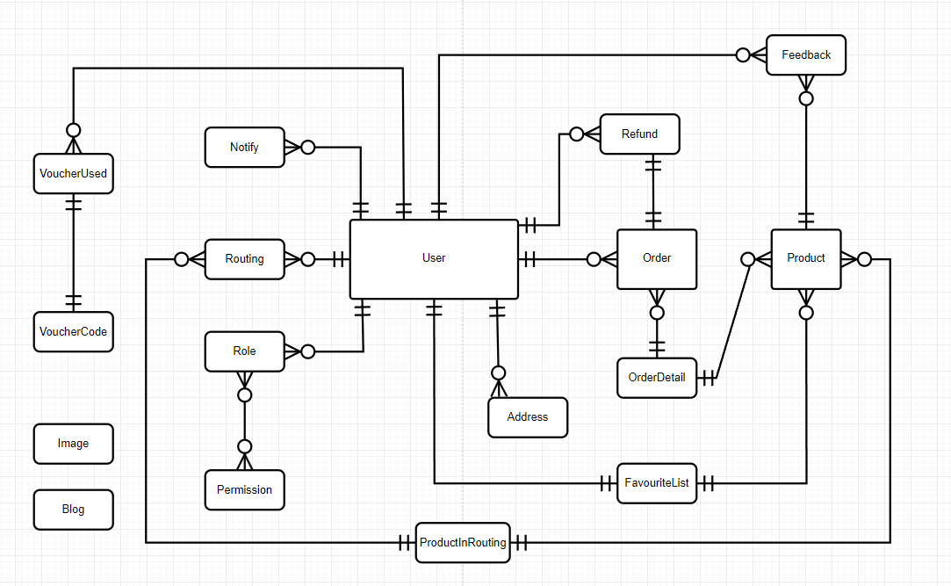

**Entities Description**

| **#** | **Entity** | **Description** |
| --- | --- | --- |
| 1 | User | Properties(**user_id**,status,user_role_id,point,address,last_activity,date_create,is_confirm,phone_number,lastname,firstname,password,username) |
| 2 | Product | Properties(**product_id**,name,description,quantity,weight,is_available,is_loved,status) |
| 3 | Order | Properties(**order_id**,user _id,date,price,is_confirm) |
| 4 | OrderDetail | Properties(**orderdetail_id,**order id,product_id,quantity,date,price) |
| 5 | Blog | Properties(**blog_id**,status,date,description,name) |
| 6 | Feedback | Properties(**feedback_id,**product id,user_id,content,star,date) |
| 7 | Routing | Properties(**routing_id**,Properties,status,price,quantity,description,name) |
| 8 | Refund | Properties(**refund_id,**user_id,order_id,description,date,is_confirm) |
| 9 | Role | Properties(**user_role_id**,name) |
| 10 | FavouriteList | Properties(**favourite_list_id**,user_id,product_id) |
| 11 | Permission | Properties(**permission_id,**user_role_id,name) |
| 12 | Image | Properties(**image_id**,relation_id,name,url,type) |
| 13 | Notify | Properties(**notify_id,**user_id,message,type,date) |
| 14 | Address | Properties(**address_id,**user_id,address,district,city_province,.block_village,is_default) |
| 15 | VoucherUsed | Properties(**id,**voucher_id,user_id) |
| 16 | VoucherCode | Properties(**voucher_id,**voucher_code,value,quantity,used) |
| 17 | ProductInRouting | Properties(**id,**product_id,routing_id) |

# II. Functional Requirements

## *Public Feature

### 1. Home Page

- Function trigger: When the user visits the website.

- Function description: This page is the first place users usually go when accessing that website.

- Function details: When a visitor lands on the site, the home page appears. The home page's function is to introduce the main content and features of the site, and to provide the user with links and useful information to navigate to other pages on the site. .

- Screen layout:

### 2. Login

- Function trigger: User clicks the “Đăng nhập” button in the Login Page.

- Function description: This function allows users with an activated account or an administrator to log in to the system. When filling in the login information completely and correctly, the system will verify and redirect the page to the homepage if it is a customer account or to the admin page if it is an admin account.

- Function details: The login function starts when the user has an account but has not logged into the system. Here users can login using the login form by filling in the email and password information on the displayed form, then pressing the login button. The system will check the login information, if it is wrong, the system will display the login page and error message again, if successful, the system will save the login data to the session and redirect to the homepage if logged in with the user account or admin page if the user fills in the login information as an admin account.

Users can also choose to log in with a social network account like Google if they click on the login icon with a social network account. The system will then redirect to the authentication page corresponding to that social network. If the authentication is successful, the system will get user information to compare with the database, if the user has not registered with that account, the system will automatically register, save data to the database and session, then transfer Navigate to the homepage and end the login function.

- Screen layout:

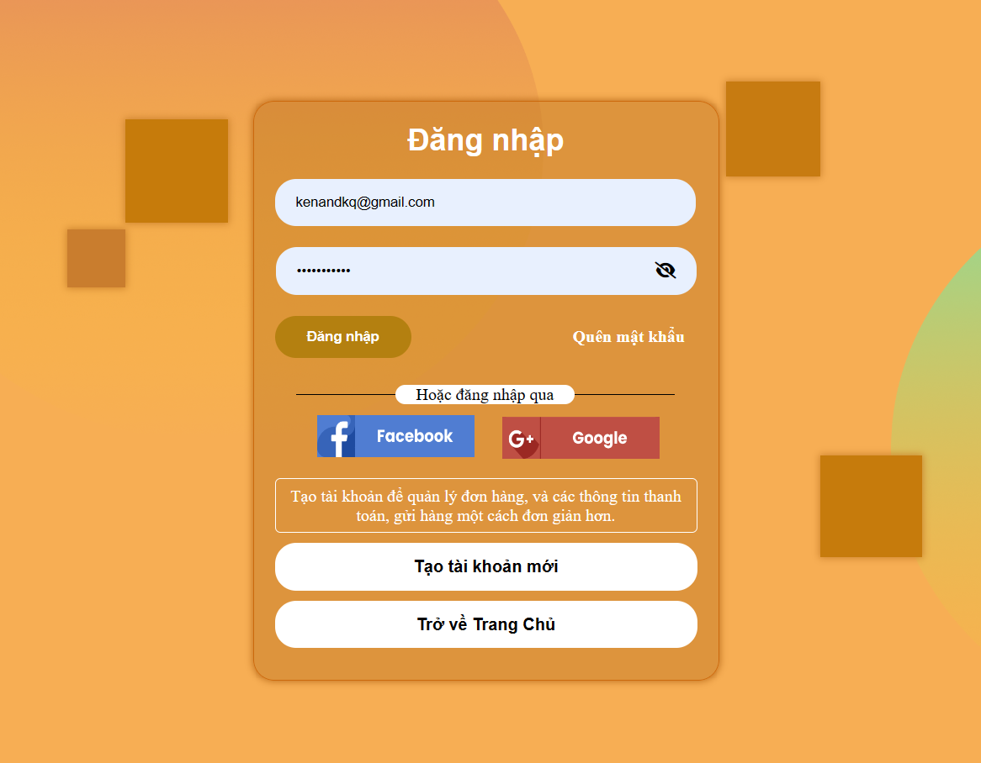

### 3. Register.

- Function trigger: When the user clicks on the “Đăng ký” button in the Register Page.

- Function description: When users need to create an account for shopping and gain discount points for next time. After registration, the account will be updated to the database, provide security, notification, authentication...

- Function details: The function will receive the information of the user, such as their email address, password and some personal information by input. System shall validate the user's input on the registration form to ensure all required fields are filled out and that the email address is in a valid format. The system shall require users to authenticate themselves with their email address and password when logging into their account. The system shall ensure that user passwords are stored securely using encryption or other industry-standard security measures. The system shall create a user profile for the user upon successful account creation, which may include personal information, preferences, or other optional details. The system shall ensure that the registration form and login functionality are accessible to users with disabilities and comply with relevant accessibility standards.

- Screen layout:

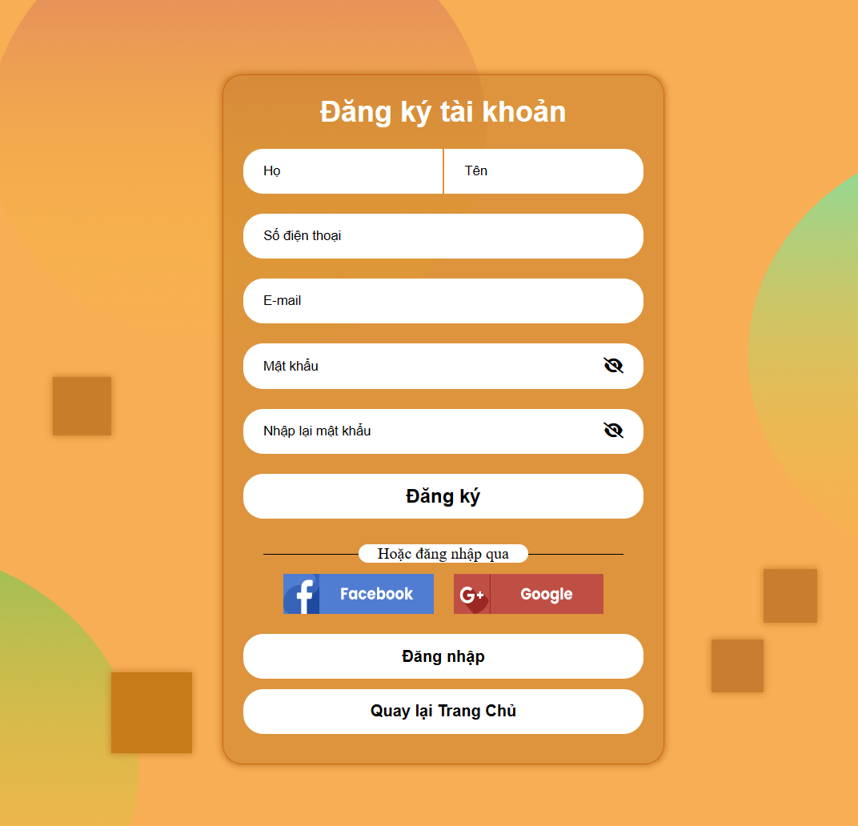

### 4. Forgot Password

- Function trigger: When the user clicks "Quên mật khẩu" in the Login Page.

- Function description: This function makes it possible for the user to create a new password when the user forgets the current password.

- Function details: When the user clicks the user icon in the header to log into the system. The User Login page will appear, in this page the words "Quên mật khẩu" will appear. After clicking, here will appear a form for users to enter the email registered on the system. The system will check the email entered by the user. If email is already registered on the system. The system will send the current password to the user email. If the entered email does not exist on the system, the system will reload the form and the message "The email entered is not registered on the system".

- Screen layout:

### 5. Web Product List

- Function trigger: When a user visits the Home page.

- Function description: Render product list and meal routing in system.

- Function details: Render a screen below, for customers to choose the product and meal which they are looking for.

- Screen layout:

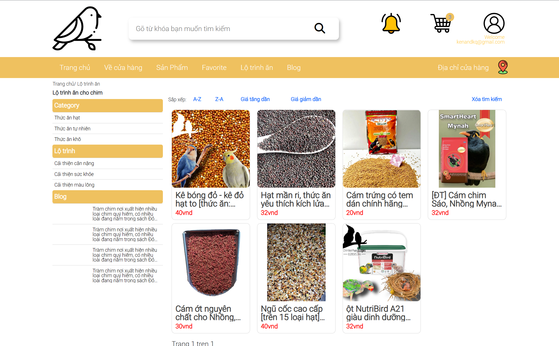

### 6. Web Product Detail

- Function trigger: When a customer clicks on the “Detail” button on a product.

- Function description: Render information of products.

- Function details: Render a screen below, showing the information of a product customer choosed.

- Screen layout:

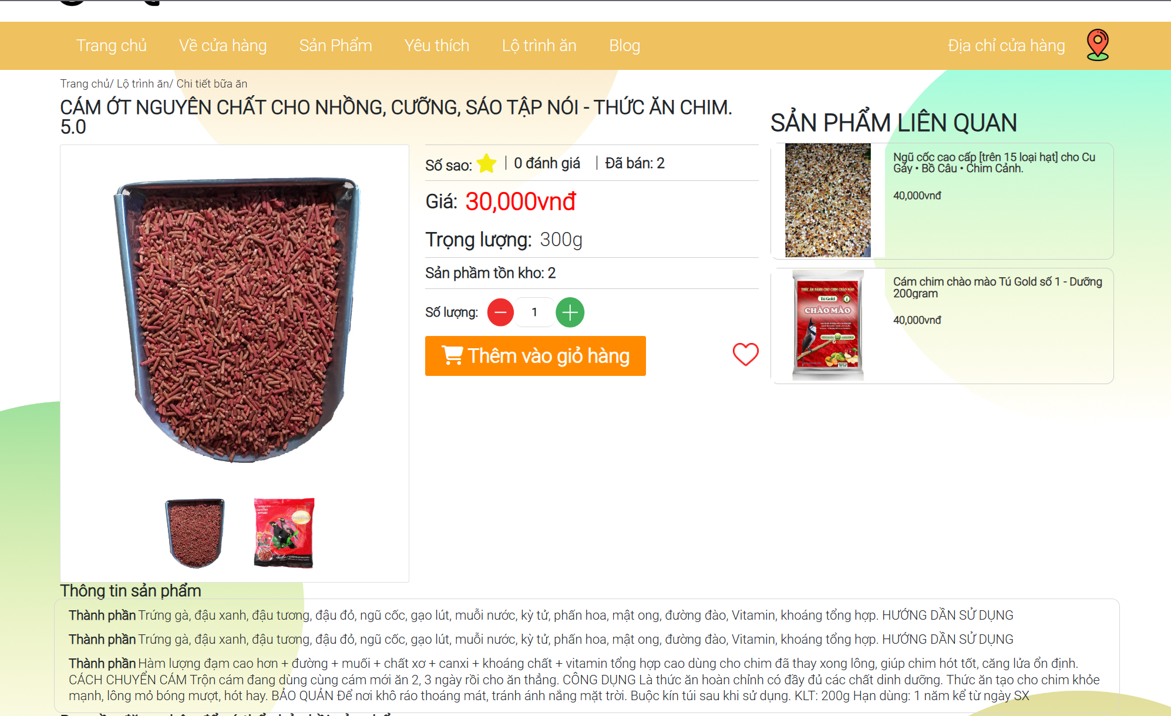

### 7. Web Meal Routing List

- Function trigger: When a user visits the Home page.

- Function description: Render product list and meal routing in system.

- Function details: Render a screen below, for customers to choose the product and meal which they are looking for.

- Screen layout:

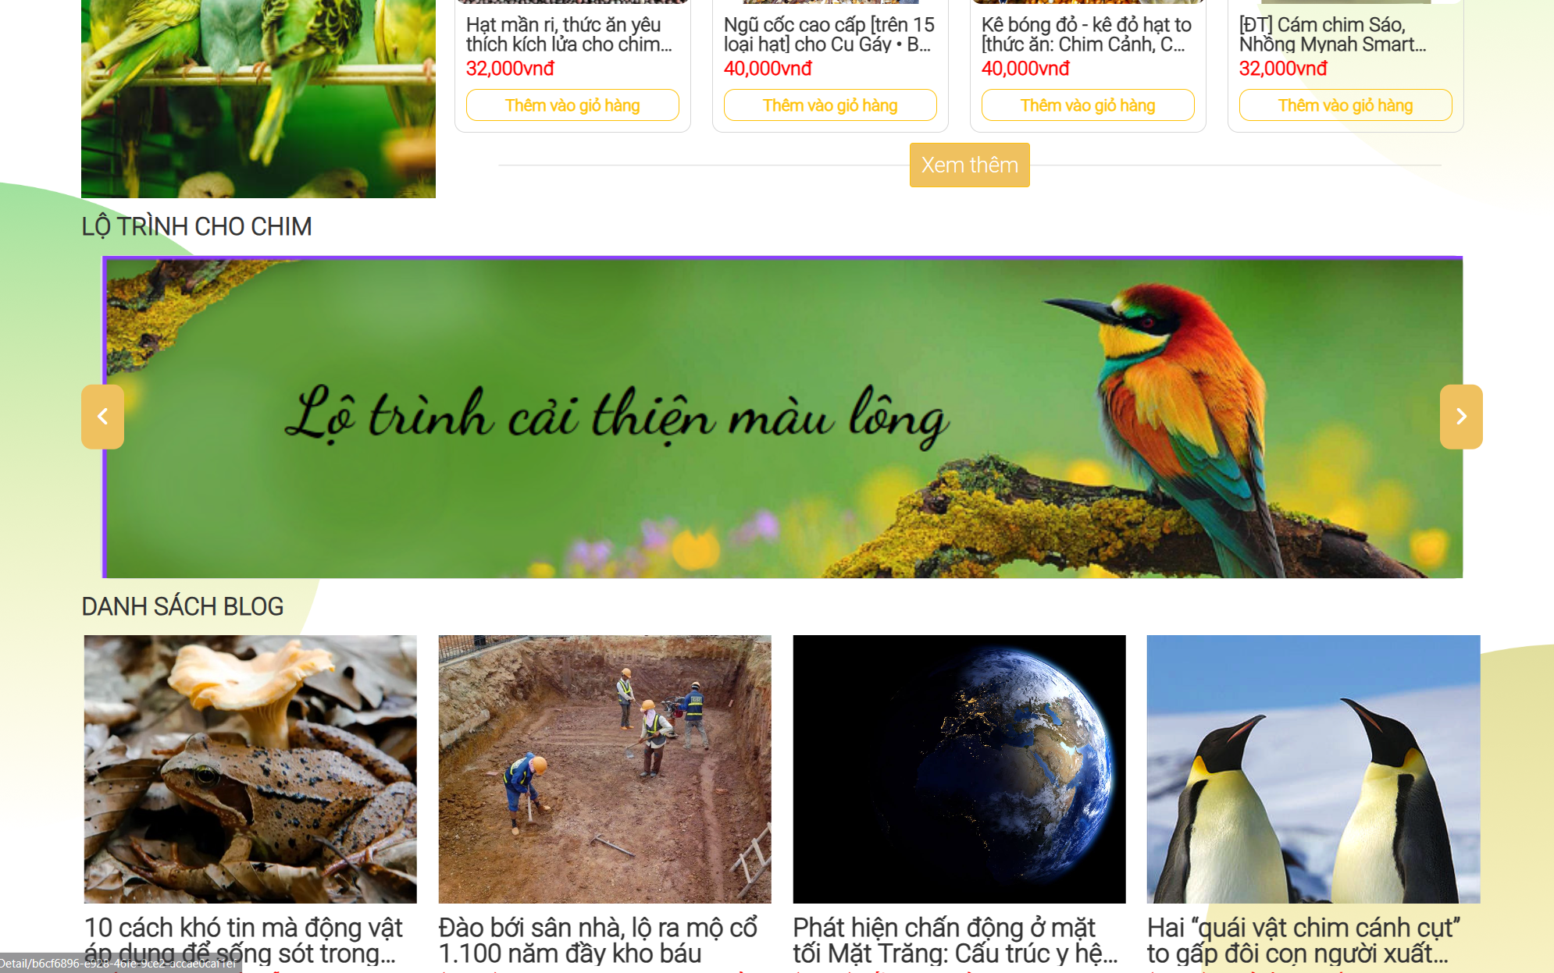

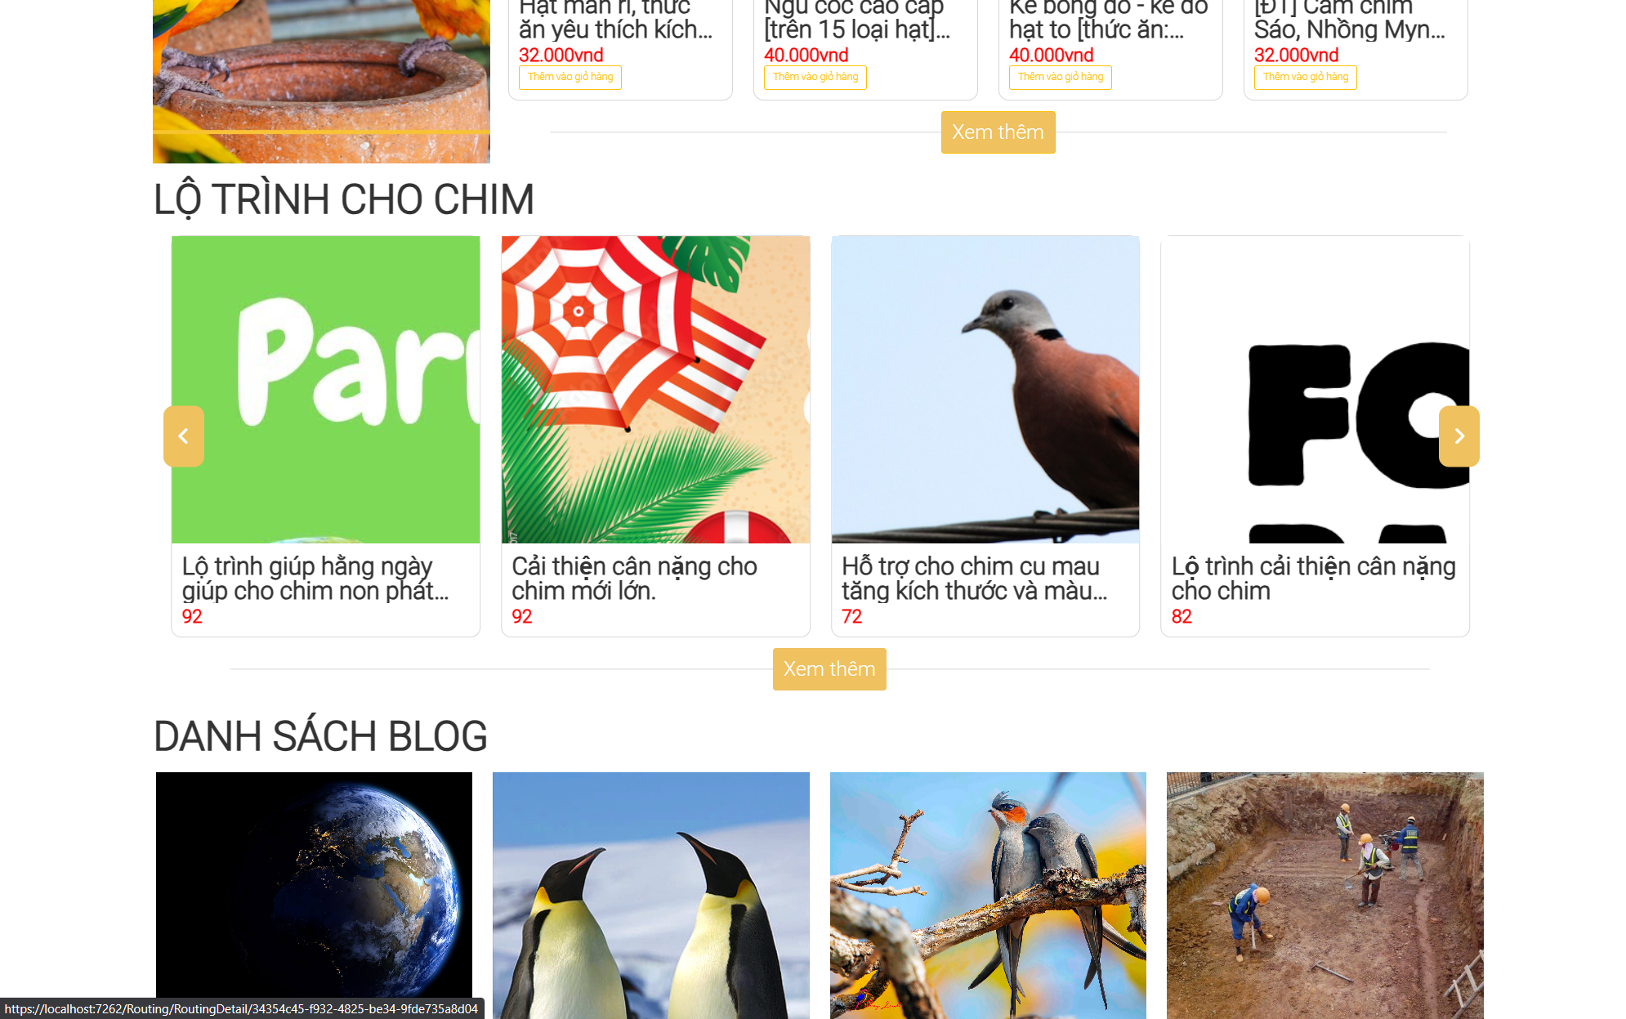

### 

### 8. Web Meal Routing Detail

- Function trigger: When a customer clicks on the “banner” of routing in the homepage.

- Function description: Render information of products.

- Function details: Render a screen below, showing the information of a product customer choosed.

- Screen layout:

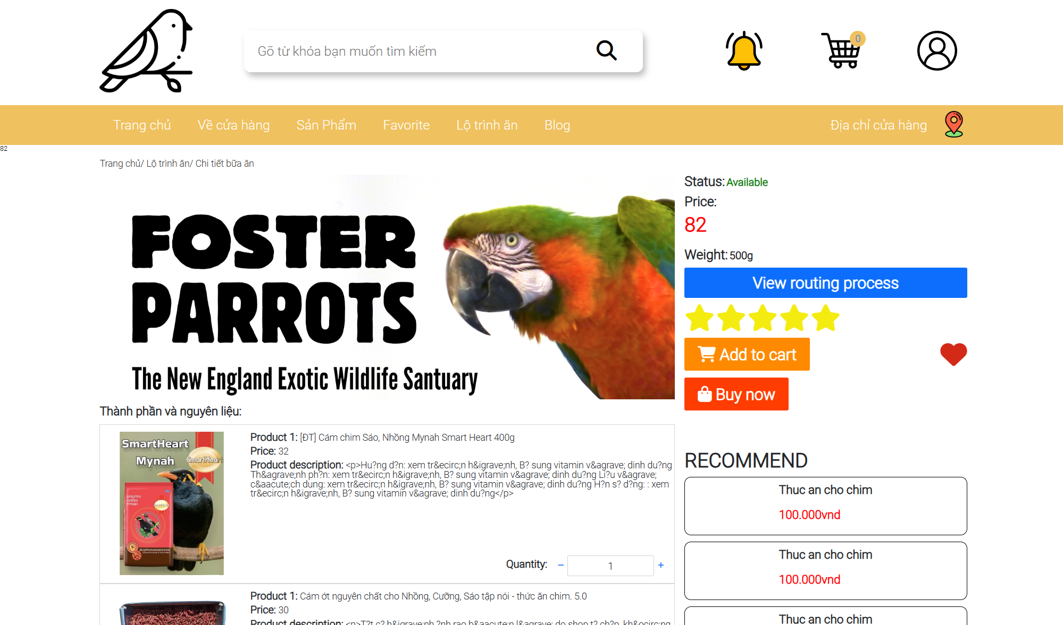

### 9. Web Blog List

- Function trigger: When a customer visit the website or they can choose Blog category in the sidebar

- Function description: Render blog list and customer can choose.

- Function details: Render a screen below, show the list of blogs for customers to choose and read.

- Screen layout:

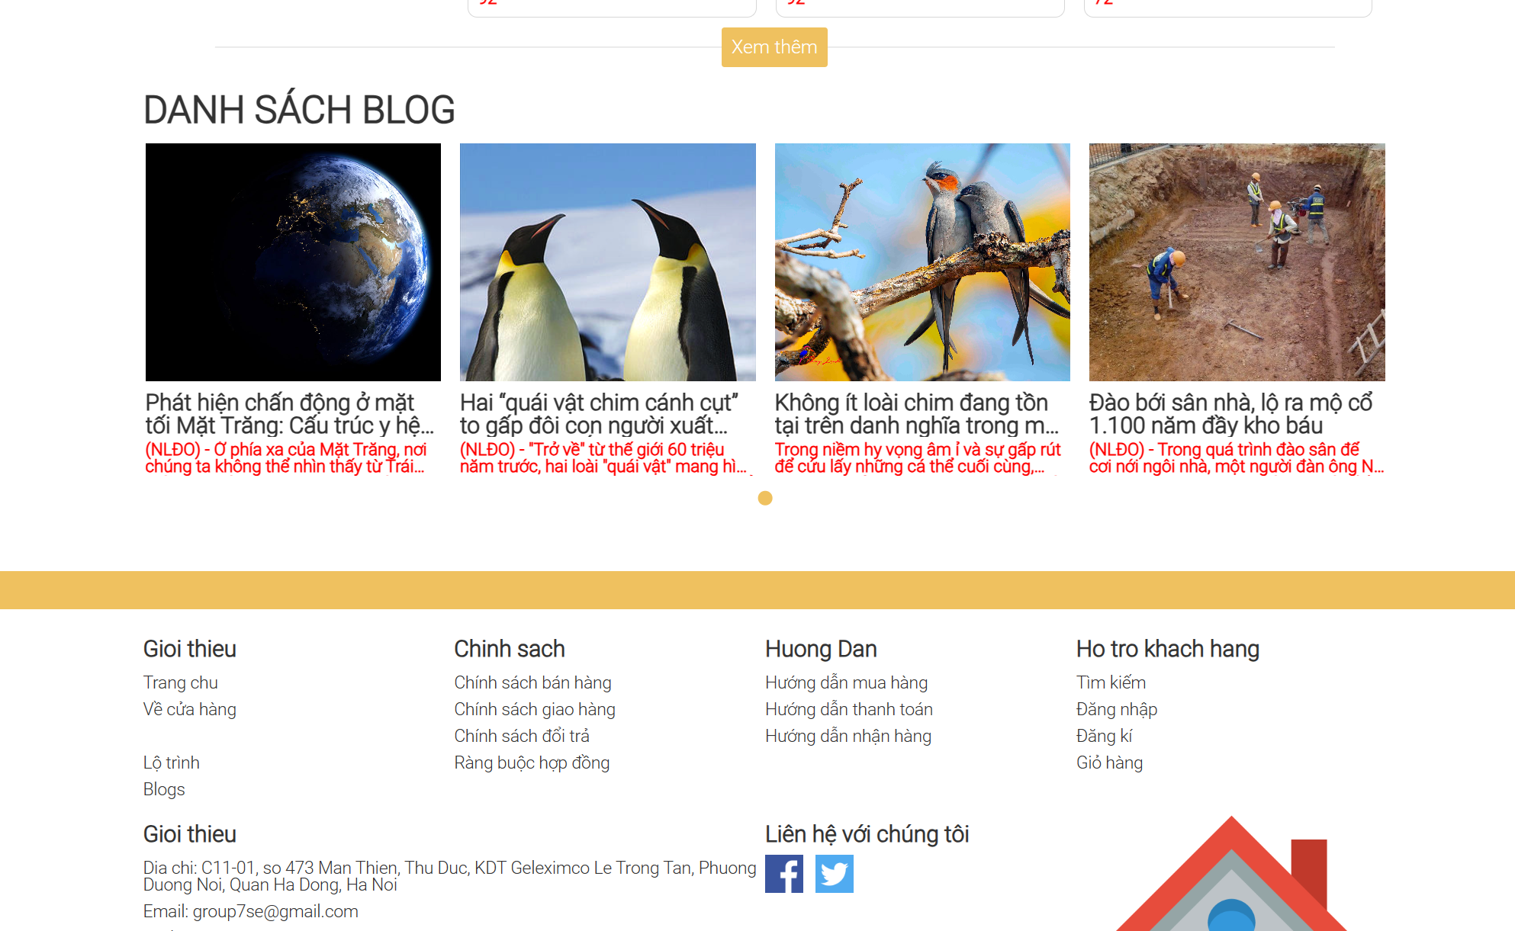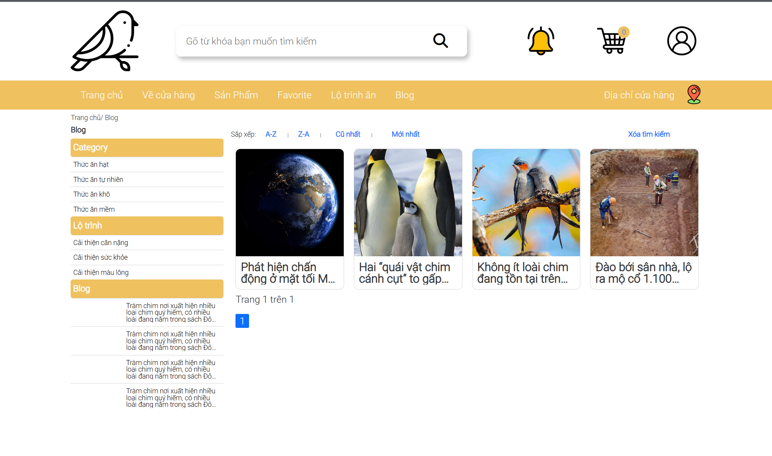

### 10. Web Blog Detail

- Function trigger: When a customer clicks on a blog page.

- Function description: Render information and story for blog page.

- Function details: Render a screen below, showing the story or the information of the blog depending on what blog the customer chooses.

- Screen layout:

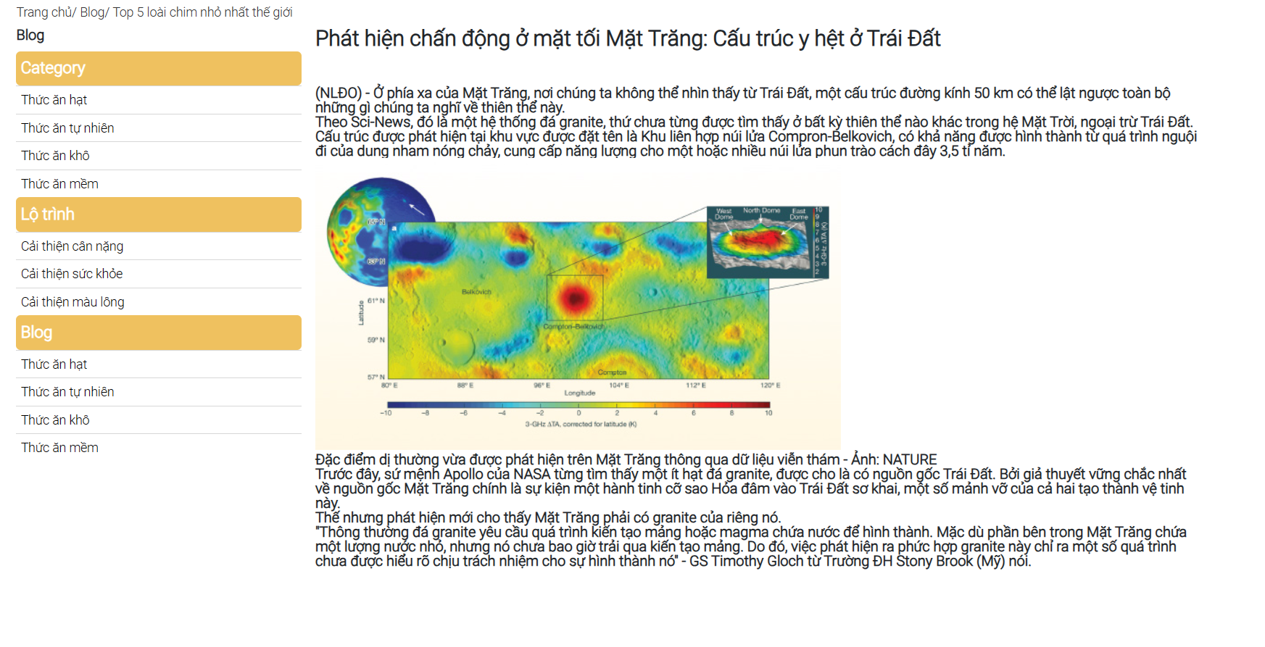

### 11. Search Product/Meal Routing

- Function trigger: Customers will choose their target to search for a product in the form filter.

- Function description: This function helps users to easily find products quickly based on available requirements.

- Function details: Users click on the search bar on the screen and type keywords related to the product to be searched. Then, click on the "Search" icon or “Enter”, a list of products related to the keyword that the user entered will be rendered on the screen. If the searched product is not suitable, the user can repeat the operation to search for the product.

- Screen layout:

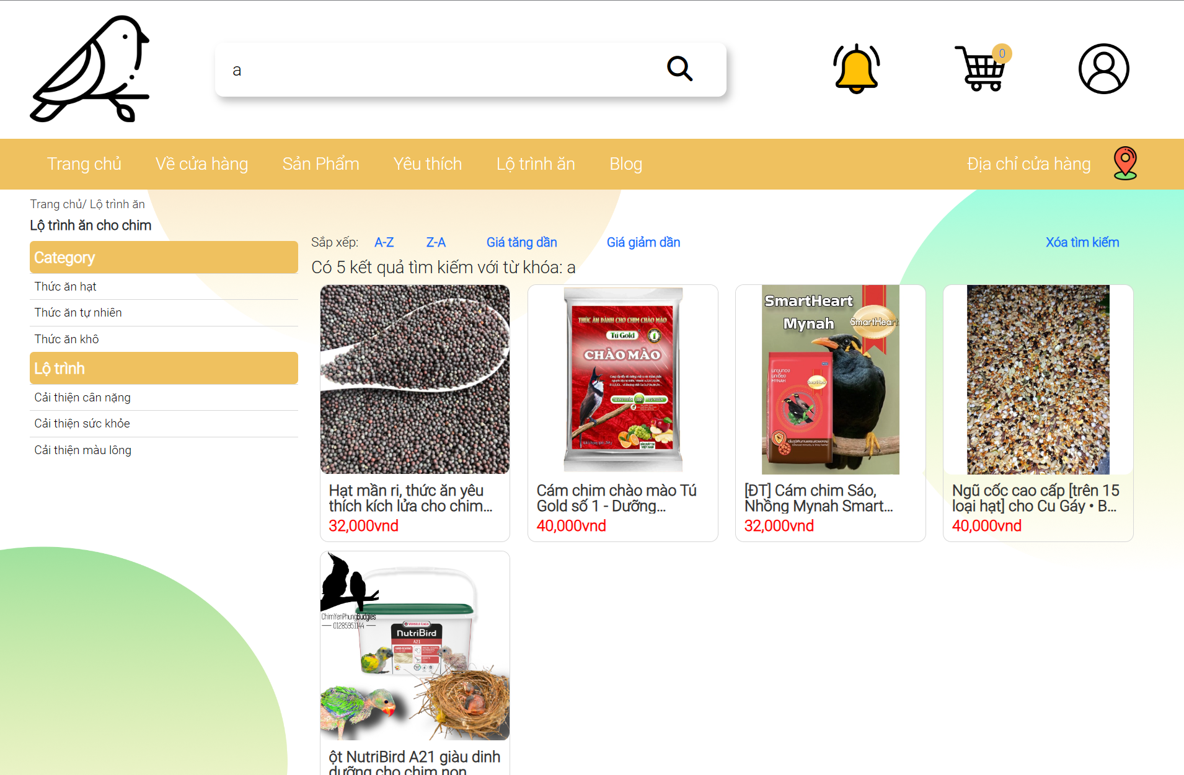

## *Common Feature

### 1. View User Profile

- Function trigger: This function triggers when a customer clicks the user icon in the Home page..

- Function description: User can view his/her registered information.

- Function details: After the user logs into the system, at the Home page, the user clicks on the user icon in the header page. The system will redirect the user to the User Profile page. Here, users can view their personal information registered on the system.

- Screen layout:

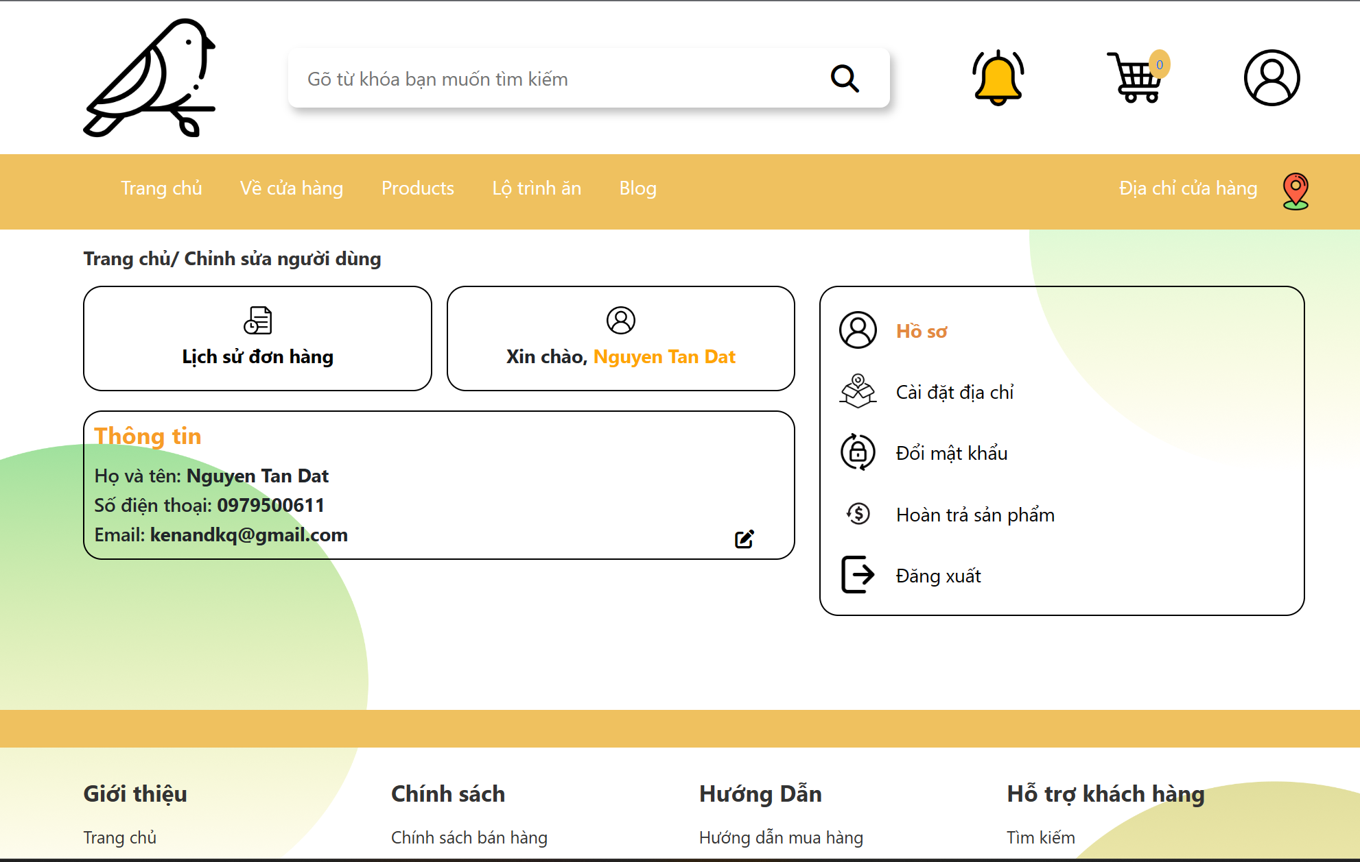

### 2. Edit User Profile

- Function trigger: This function triggers when a customer clicks the "Cập nhật" button in the "Hồ Sơ" section of the User Profile page.

- Function description: User can edit his/her registered information.

- Function details: Display a below screen, similar user profile page but with editable data.

- Screen layout:

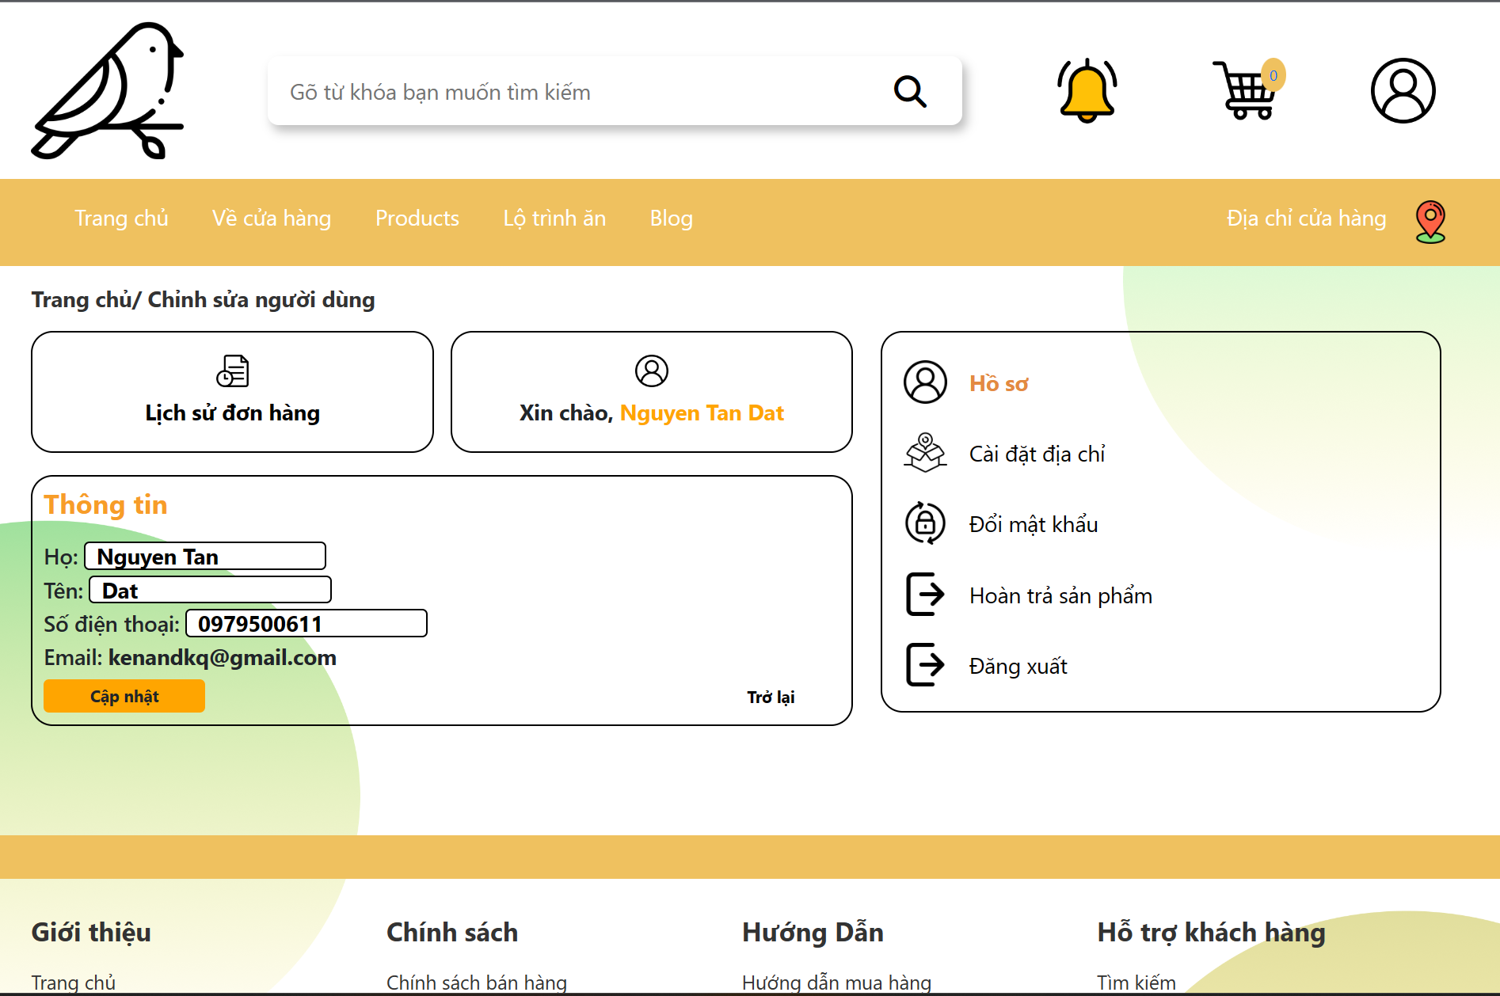

### 3. Change Password

- Function trigger: Customer clicks on “Đổi mật khẩu” in the User Profile page.

- Function description: User can change set password to new password.

- Function details: In the User Profile page, the user clicks on "Quên mật khẩu", the system will appear a form asking the user to enter a new password, then the system will send an authentication form asking the user to enter the username and the password you are using to confirm. If the authentication is successful, the new password will be changed. If the authentication fails or the user closes the authentication form, the current password will be preserved and will not be changed..

- Screen layout:

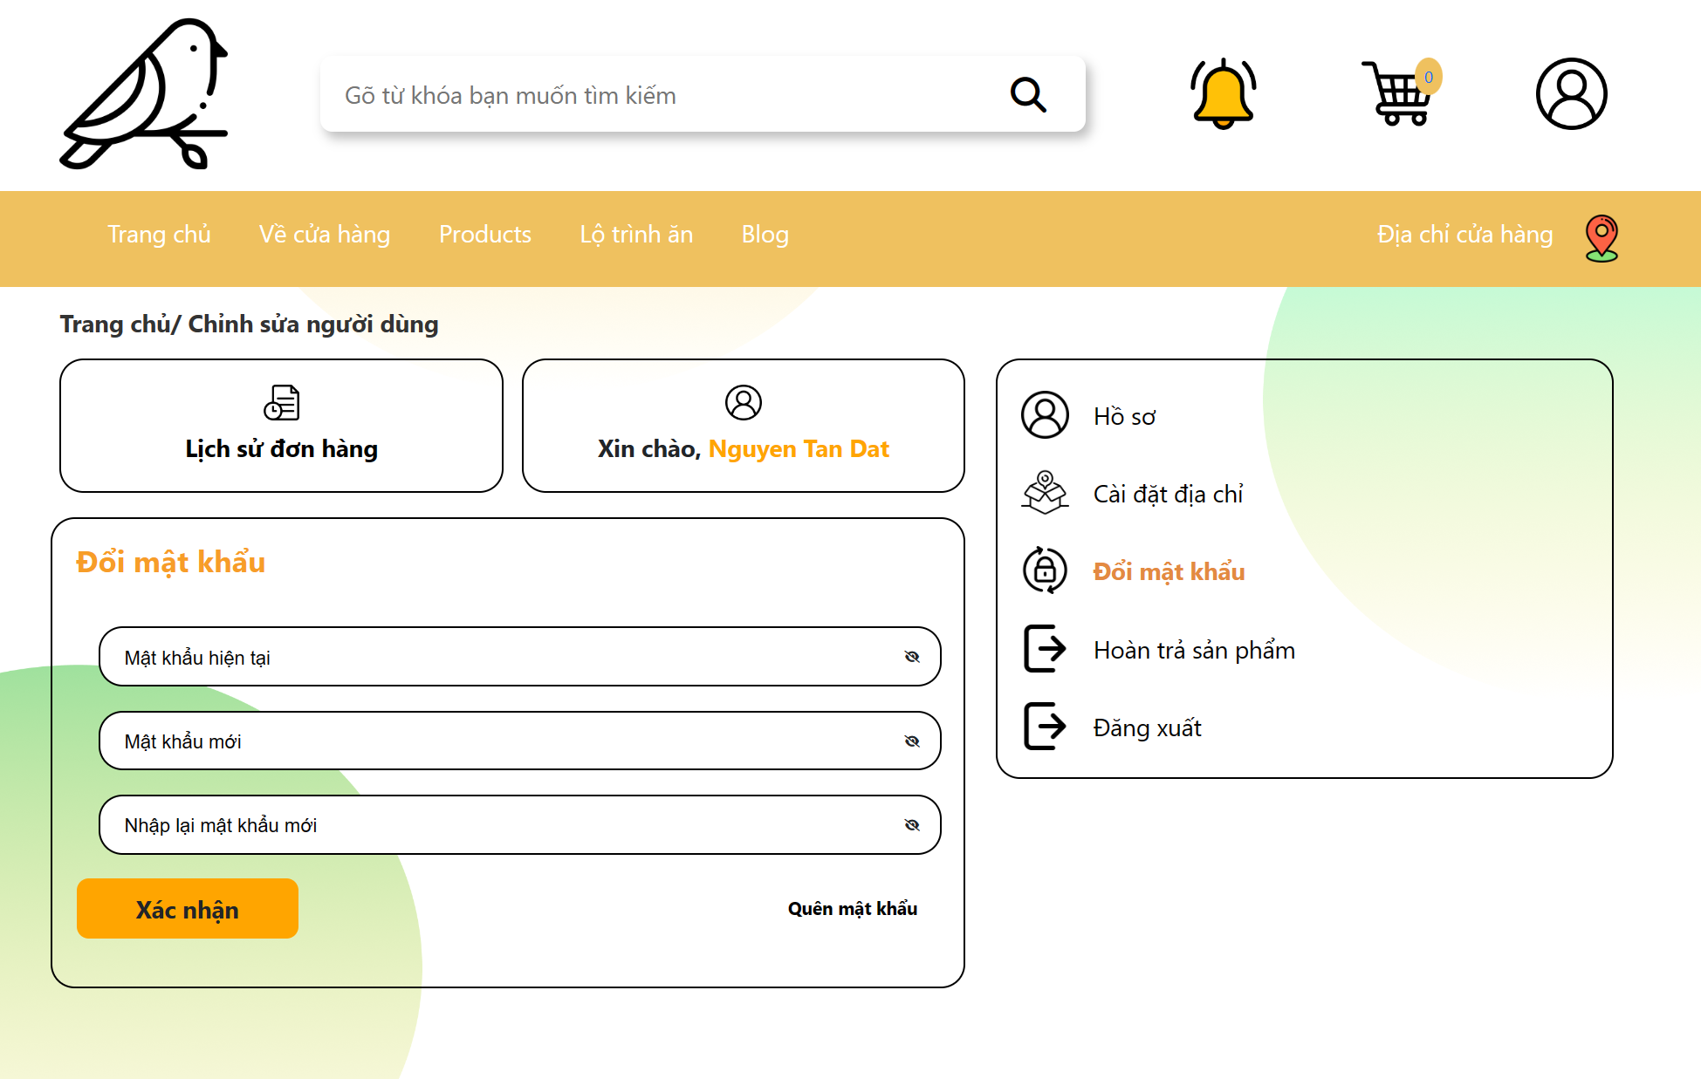

### 4. Log out

- Function trigger: When the user clicks the button with name “Đăng xuất” on screen.

- Function description: The function allows users to view dashboard page

- Function details: The feature will render the screen below to show detail data of system.

- Screen layout:

## *Admin Feature

### 1. Dashboard

- Function trigger: When the user login with an admin account.

- Function description: The function allows users to log out of the system and return to the home page.

- Function details: The logout function starts when the user is logged in in the system and wants to log out the account from the system. On the User Profile Page the user will press the logout button, the system will destroy all cookies of the user during this login session and return to the homepage.

- Screen layout: 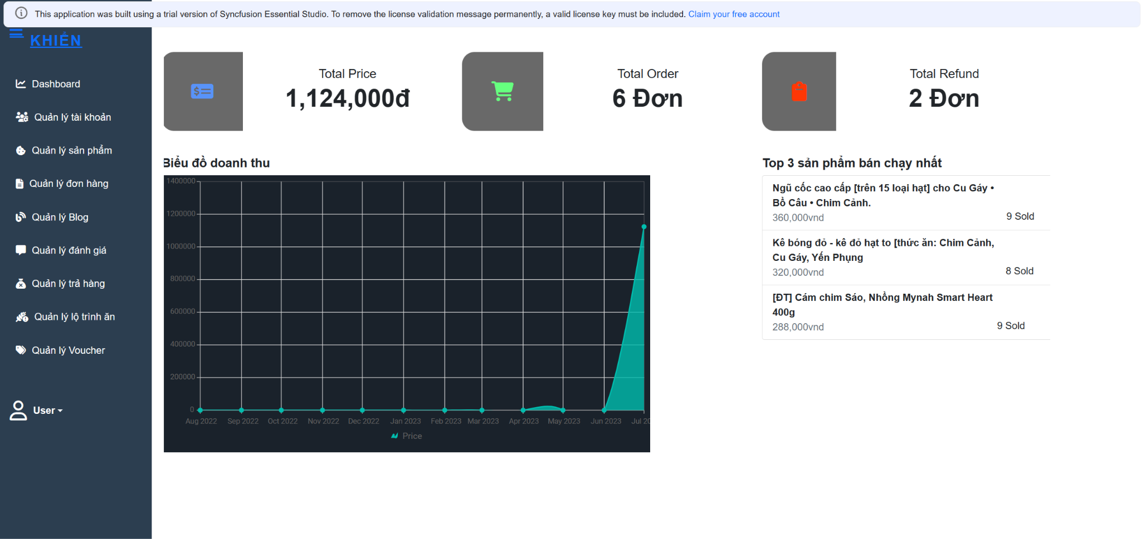

### 2. Manage Account

#### a. View Account List

- Function trigger: When the user clicks the button with name “Quản lý tài khoản” on screen.

- Function description: The function allows the admin to view the account list registered in the system.

- Function details: Render a screen below.

- Screen layout:

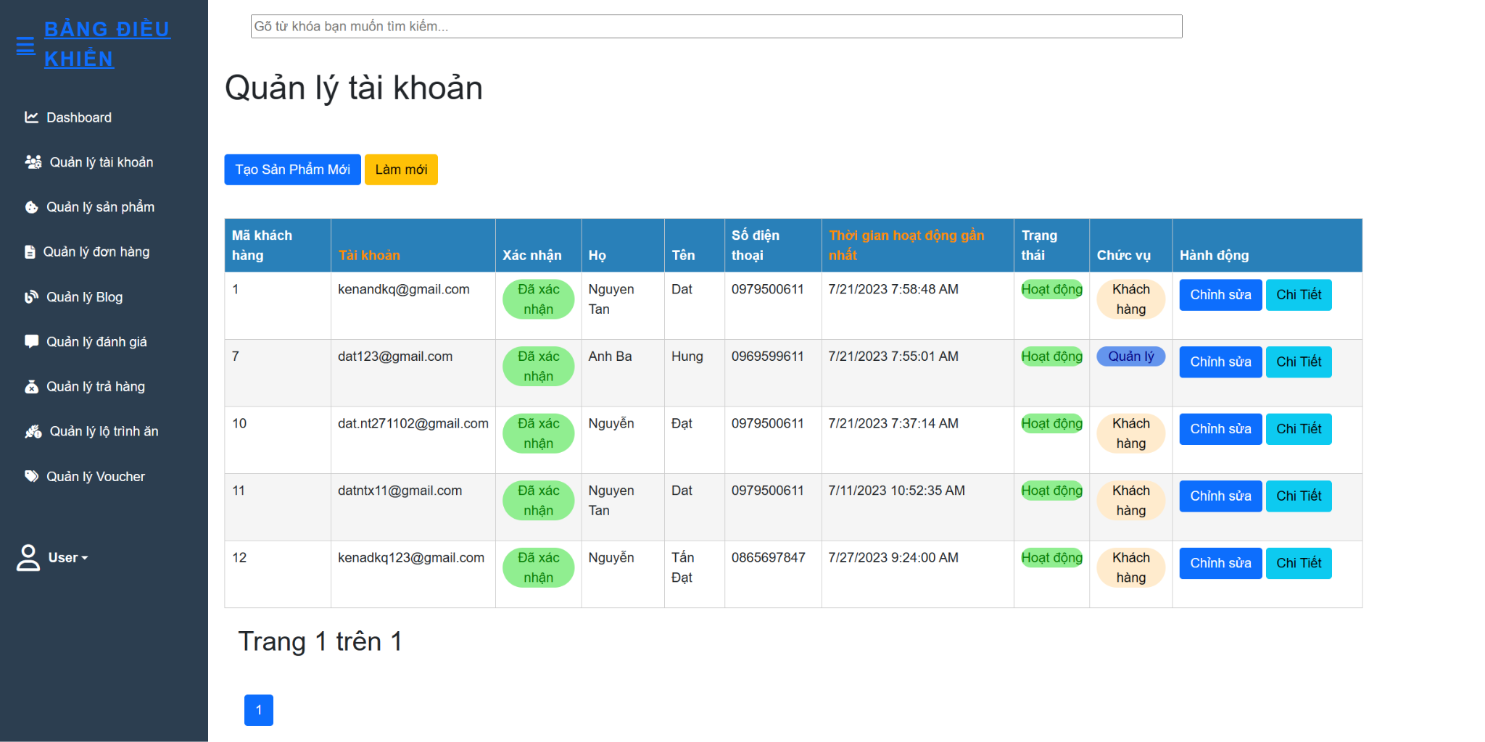

#### b. View Account Detail

- Function trigger: When the user clicks the button with name “Chi tiết” on the Manage Account page.

- Function description: The function allows admin to view details of the account list registered in the system.

- Function details: Render a screen below.

- Screen layout:

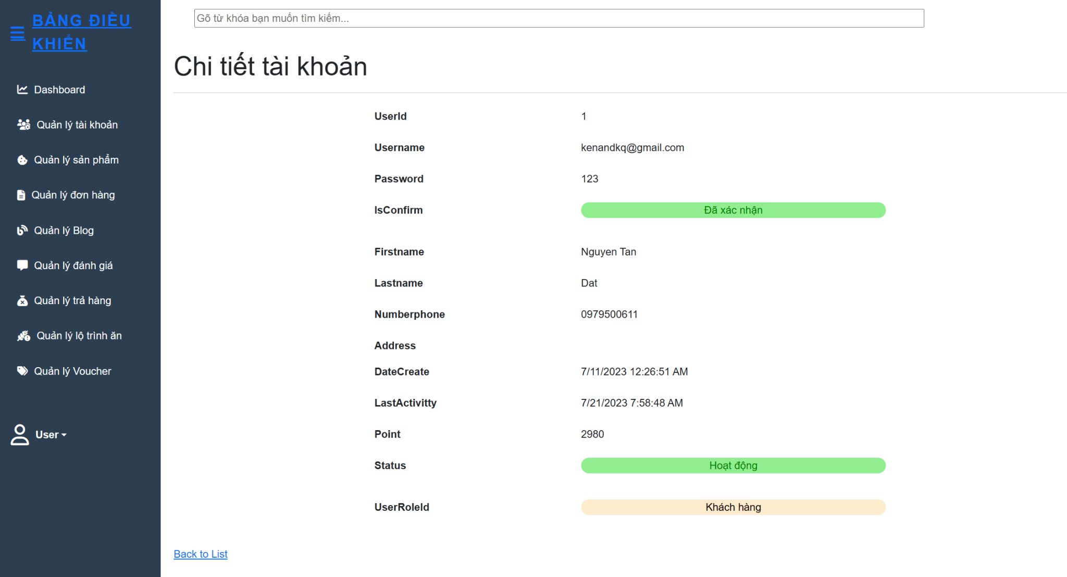

#### c. Edit Account

- Function trigger: When the user clicks the button with name “Chỉnh sửa” on the Account Detail page.

- Function description: The function that allows admin to edit personal account information of accounts registered on the system.

- Function details: This function may include features to change the user's personal information. Render a screen below.

- Screen layout:

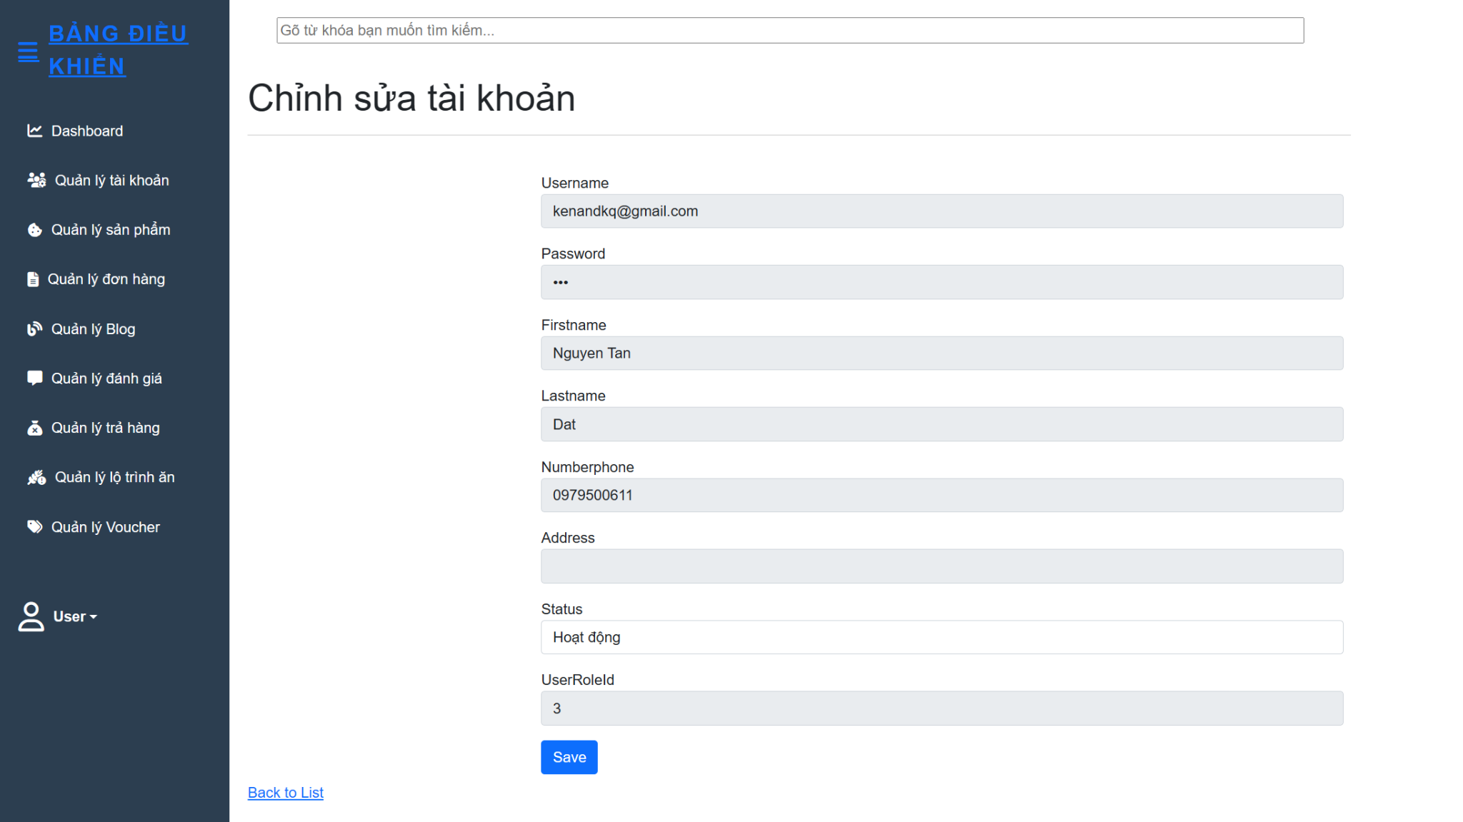

#### d. Block Account

- Function trigger: When the user clicks the button with name “Chỉnh sửa” on the Account Detail page.

- Function description: The function that allows admin to edit the active status of accounts registered on the system.

- Function details: This function has the same Edit Account but it allows the admin to edit the active status of the account. Render a screen below.

- Screen layout:

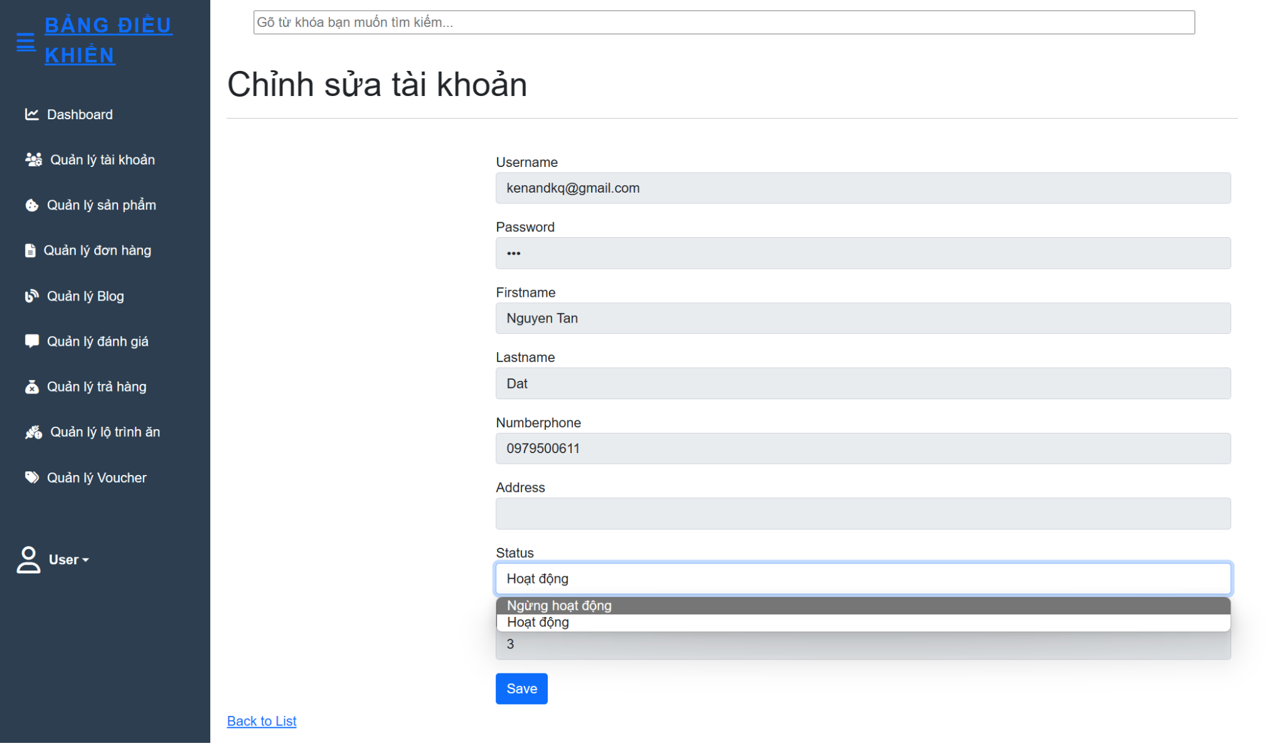

#### e. Search Account

- Function trigger: When the user clicks the Search icon on the Account Detail page.

- Function description: The function that allows admin to search accounts registered on the system.

- Function details: Render a screen below.

- Screen layout:

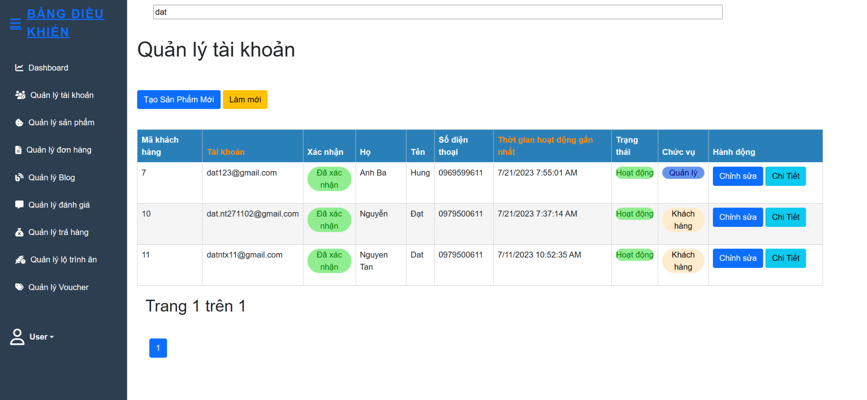

#### f. Add Account With Role Staff

- Function trigger: When the user clicks the “Thêm tài khoản” on the Account Detail page.

- Function description: The function that allows admin to add accounts with role staff into the system.

- Function details: Render a screen below.

- Screen layout:

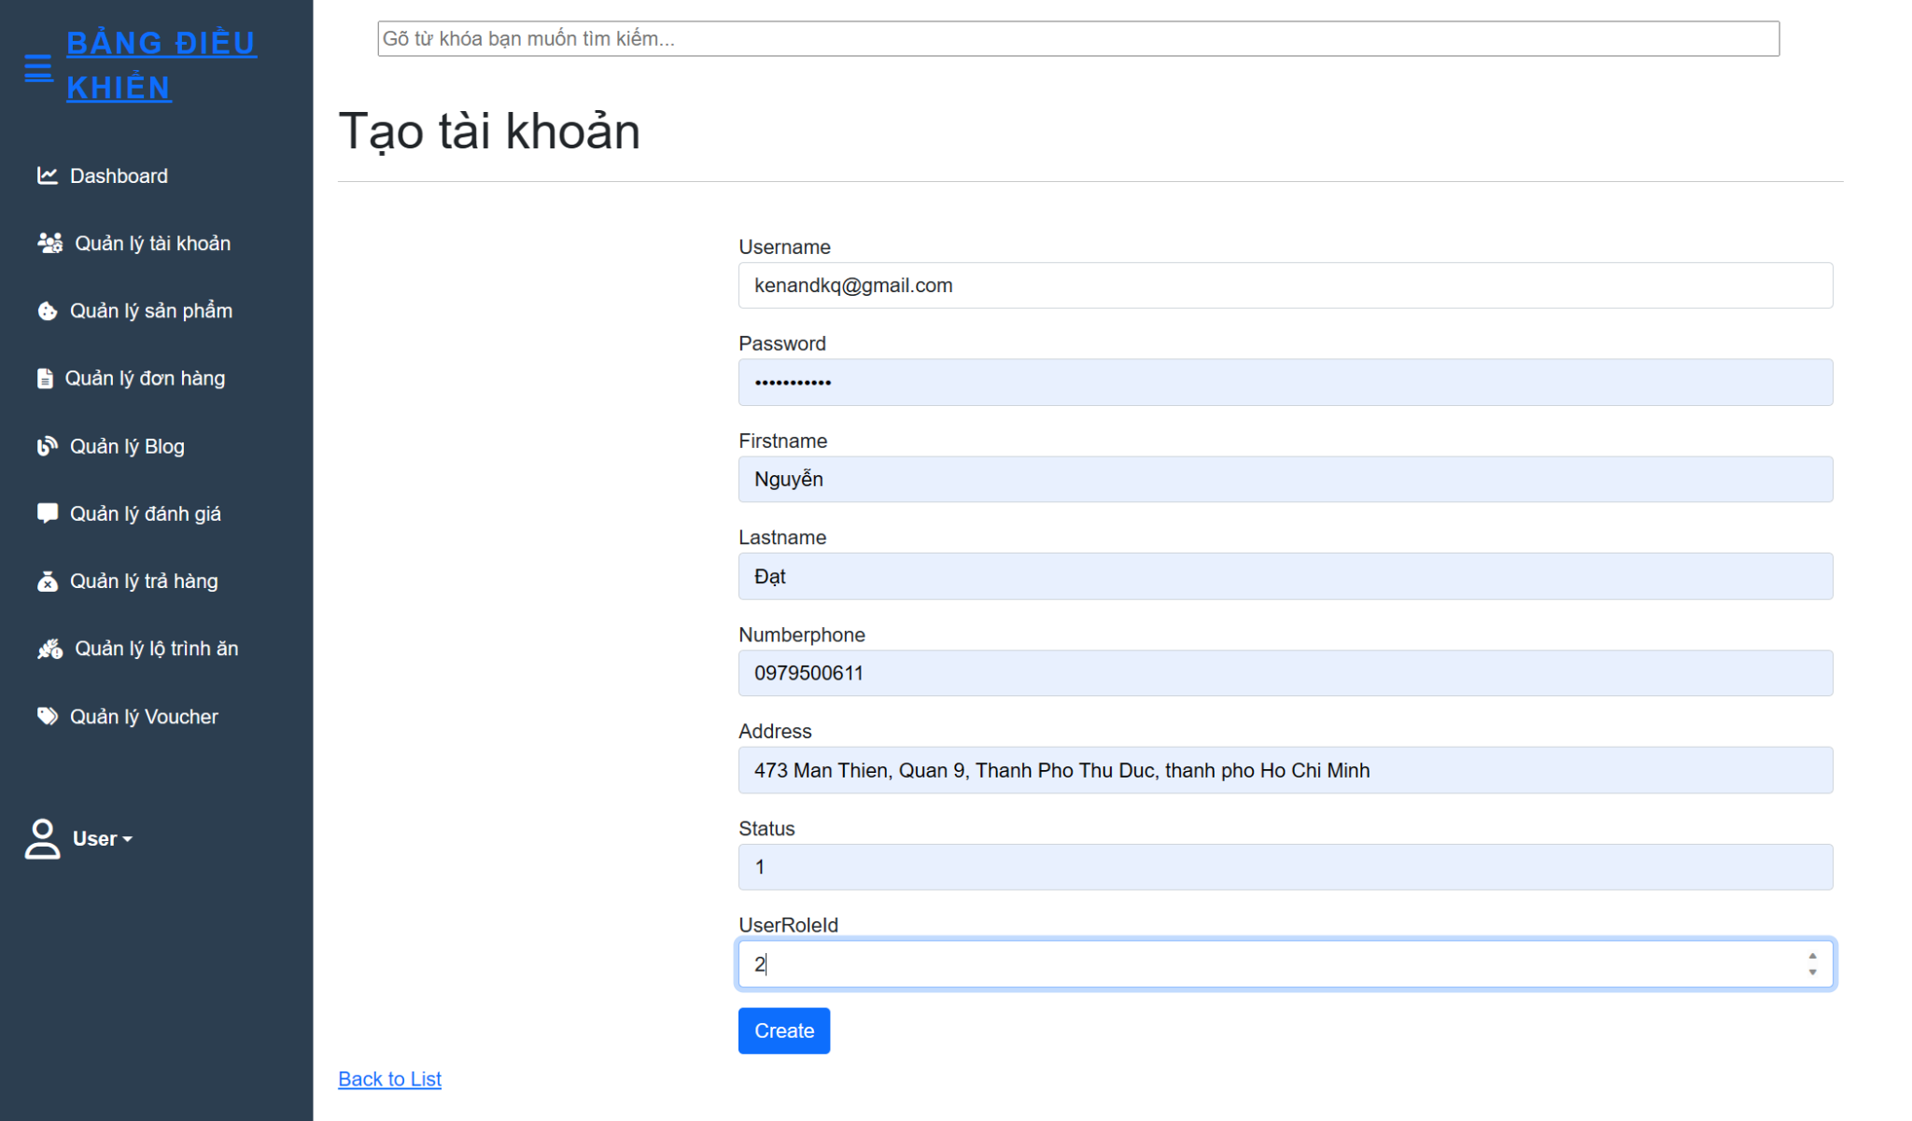

## *Staff Feature

### 1. Manage Product

#### a. View Product List

- Function trigger: When staff click on “Product Management” in the sidebar of Management Page.

- Function description: Staff can manage the product system through a list of products in the product management screen.

- Function details: Render a screen below, allow staff to edit product lists and update them or add a new product by clicking on the add button.

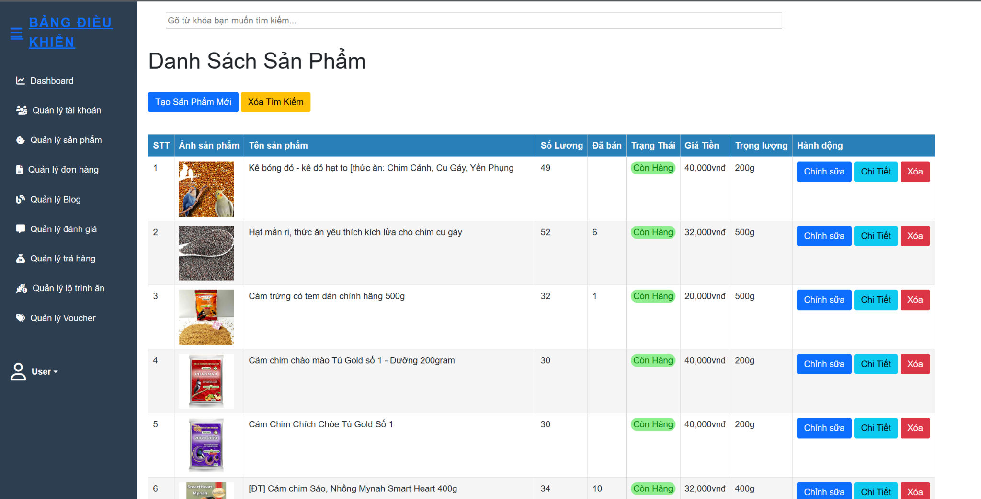

#### b. View Product Detail

- Function trigger: When a customer clicks on the “detail” button on the Product Management page

- Function description: Render information of products.

- Function details: Render a screen below, Display information of a product that staff want to see details.

- Screen layout:

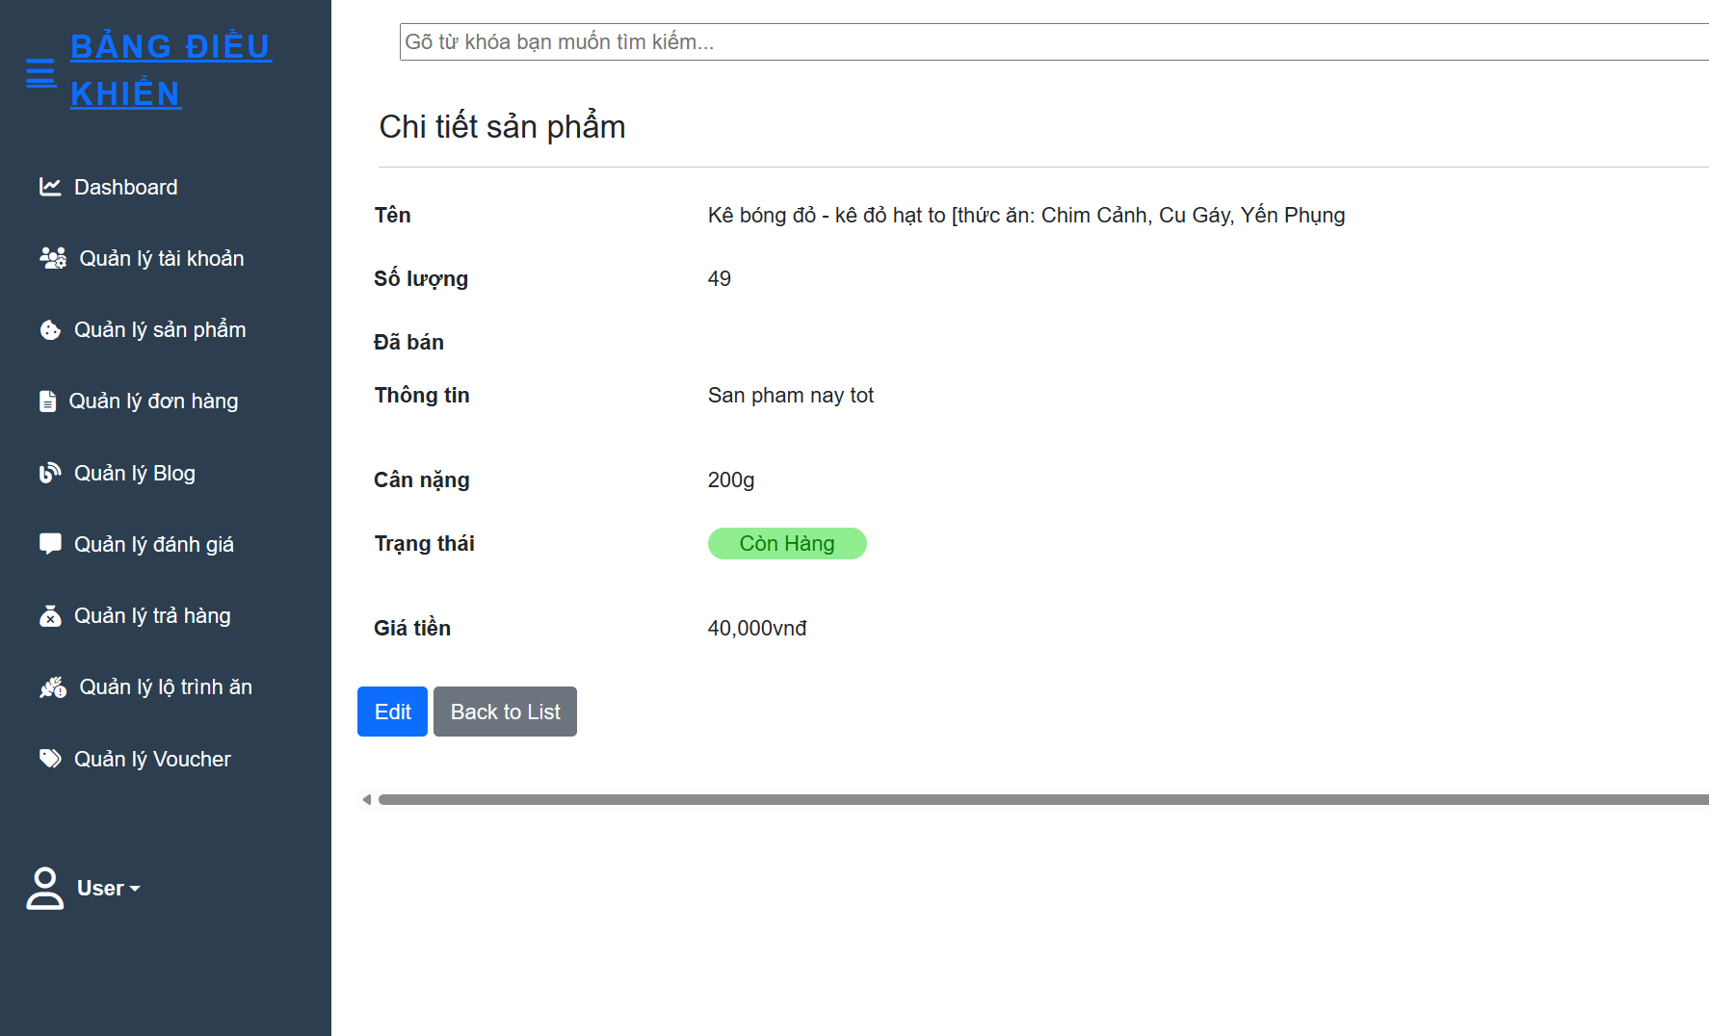

#### c. Search Product

- Function trigger: staff will choose their target to search for a product in the form filter.

- Function description: This function helps staff to easily find products quickly based on available requirements.

- Function details: Staff click on the search bar on the screen and type keywords related to the product to be searched. Then, click on the "Search" button or “Enter”, a list of products related to the keyword that the user entered will be rendered on the screen. If the searched product is not suitable, the staff can repeat the operation to search for the product.

- Screen layout:

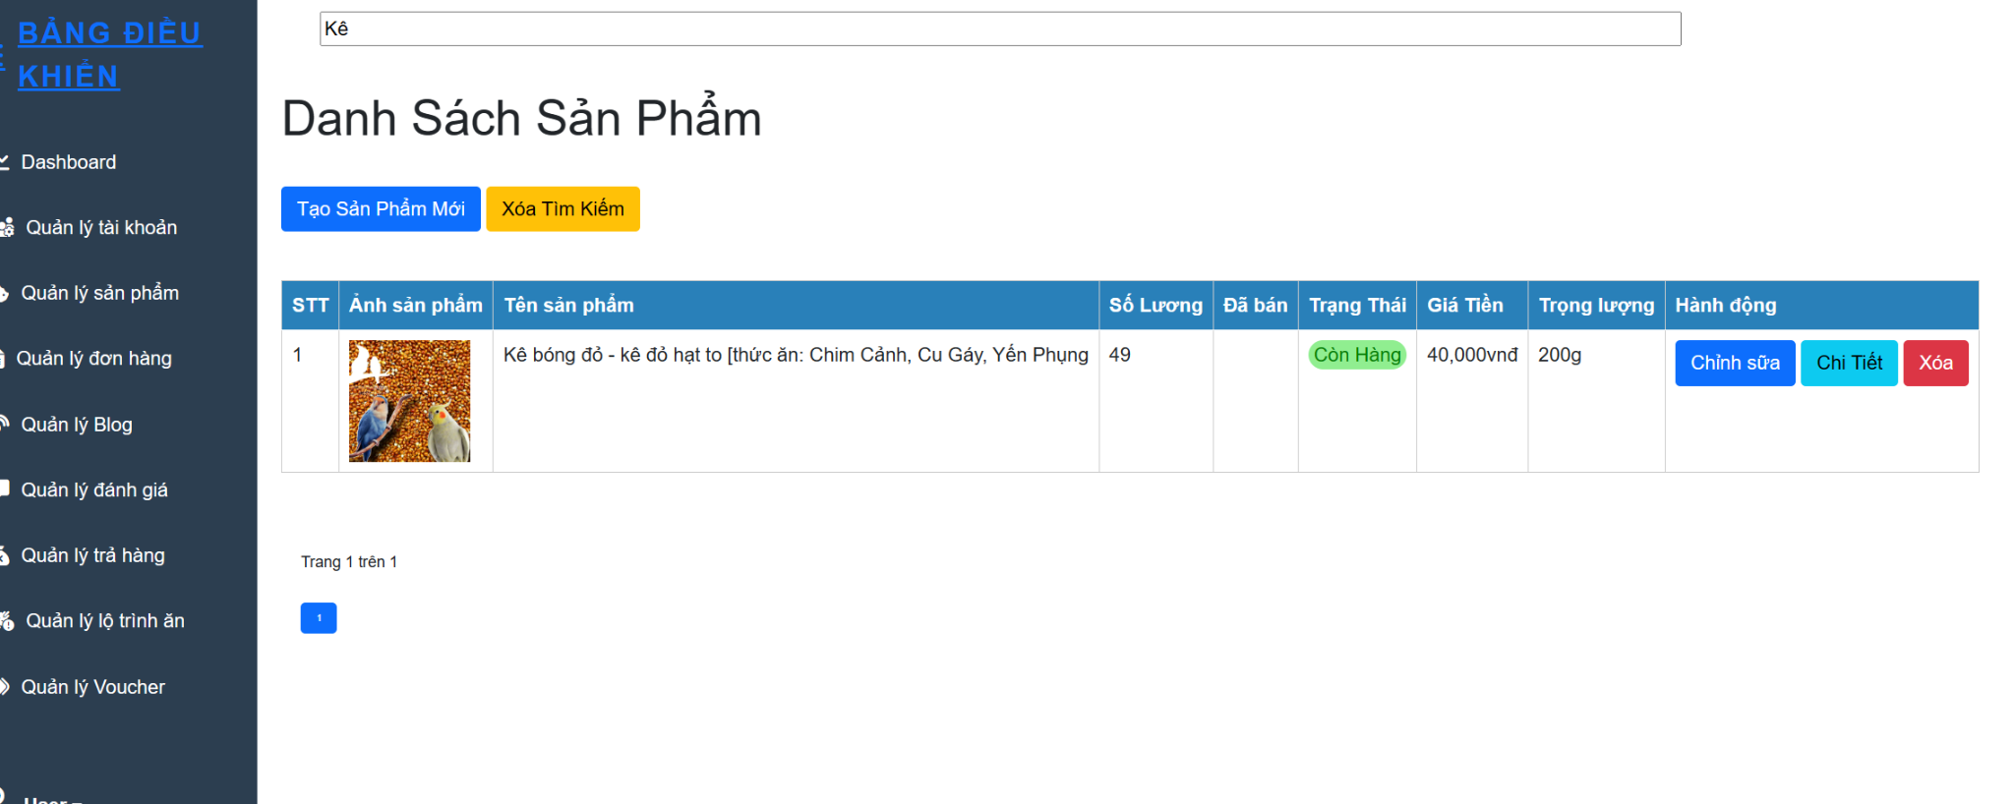

#### d. Add New Product

- Function trigger: When staff click “Add” button on the Product Management page

- Function description: This function allows staff to add new product routing including name, details, price,id.

- Function details: Add Product function starts when the staff go to the management page and select the Product Management. When staff click the “Add” button, the system will display a form for the staff to fill in the new product information. After the staff clicks the “add” button, the information including the name, id,details and price will be saved in the database. If the process is successful, a new product routing will be added to the system.

- Screen layout:

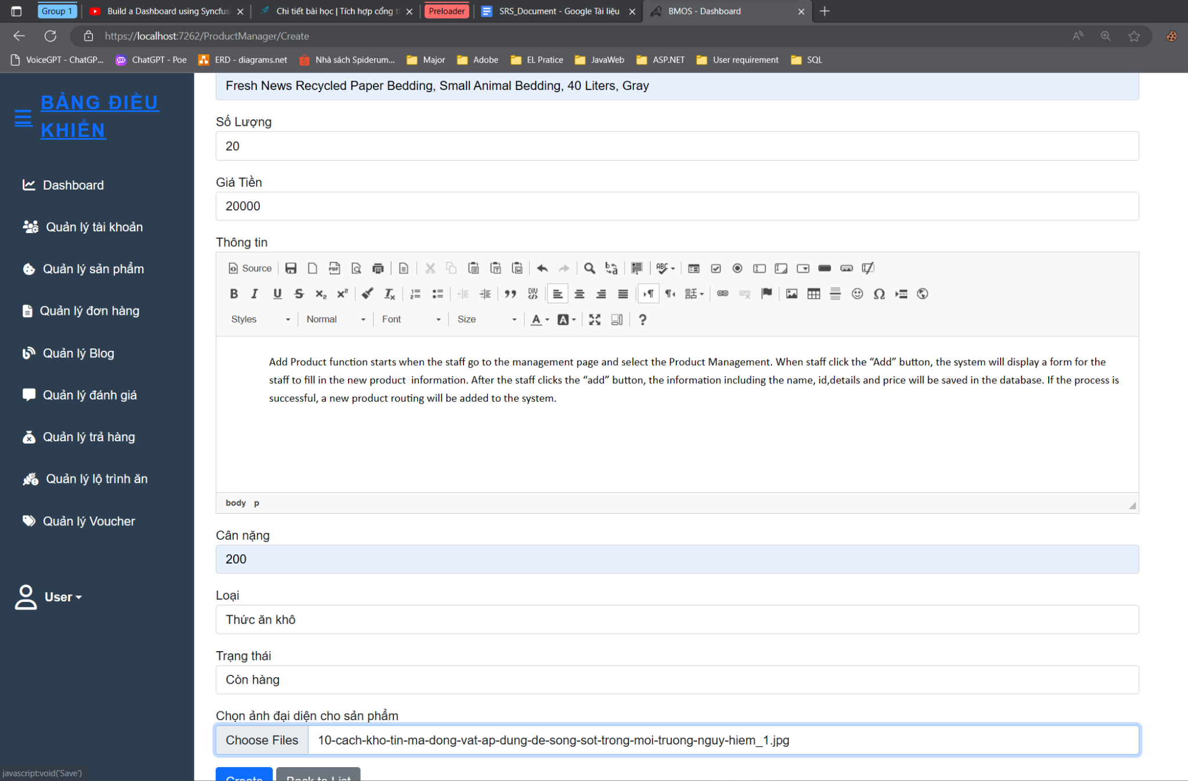

#### e. Edit Product

- Function trigger: When staff clicks the “Edit” button in the Product Management page.

- Function description: This function allows Staff edit information including name, price, details of the previously added product.

- Function details: Edit Product starts when the staff go to the management page and select the Product Management. The system will load the data on the database and a list of meal routing has been added. Here, Staff will click the Edit button at the Product you want to edit, a detailed information form of the selected Product will appear, Staff will enter the information to be edited in the form and then click "Edit" to complete. The modified meal routing information is updated on the database and reloaded.

- Screen layout:

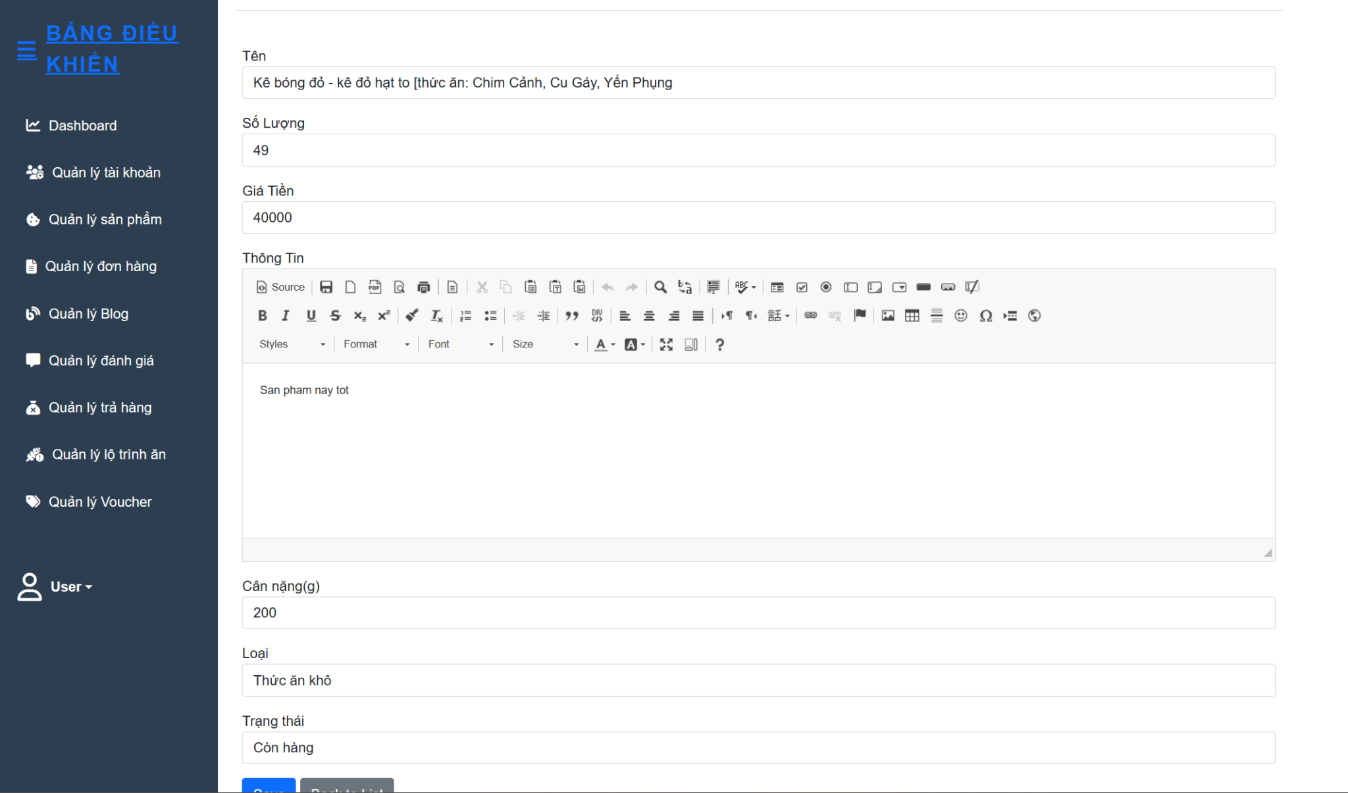

#### f. Remove Product

- Function trigger: When staff clicks the “Remove” button in the Product Management page.

- Function description: This function allows Staff to remove products.

- Function details:Remove Product starts when the Staff goes to the management page and selects the Product Management. The system will load the data on the database and a list of meal routing has been added. Here, Staff will click the "Remove" button at the Product they want to remove. The system will delete the data of Meal Routing on the database and reload the Product Management page.

- Screen layout: 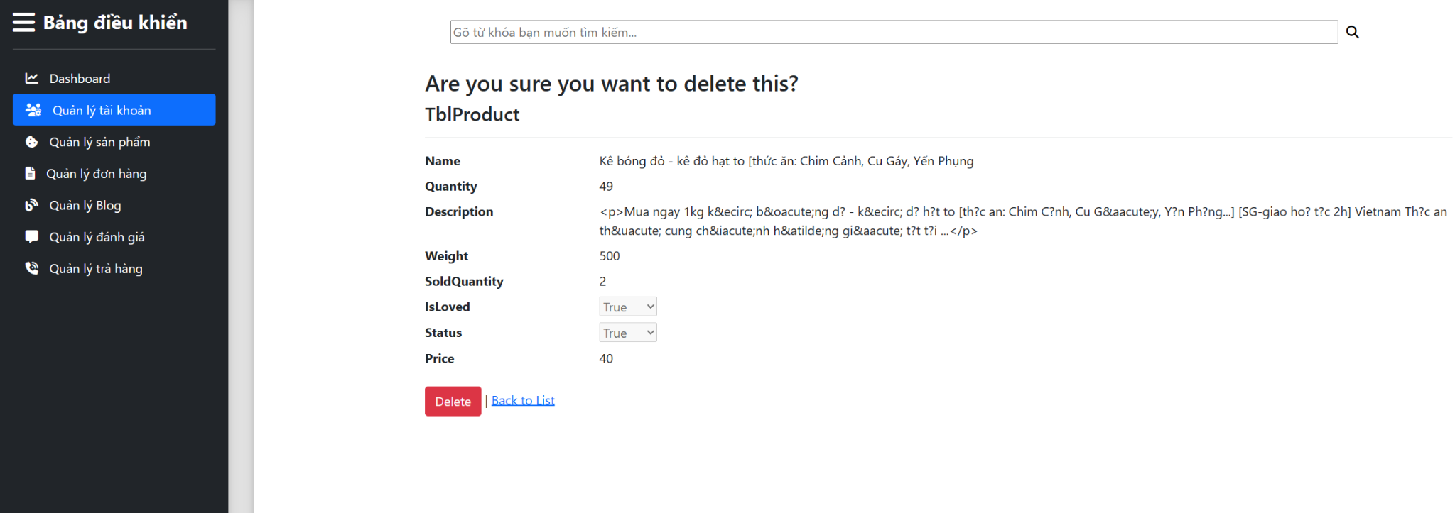

### 2. Manage Meal Routing

#### a. View Meal Routing List

- Function trigger: When staff click on “Meal routing Management” in the sidebar of Management Page.

- Function description: Staff can manage the meal system through a list of products in the meal routing management screen.

- Function details: Render a screen below, allow staff to edit product lists and update them or add a new meal by clicking on the add button.

- Screen layout: 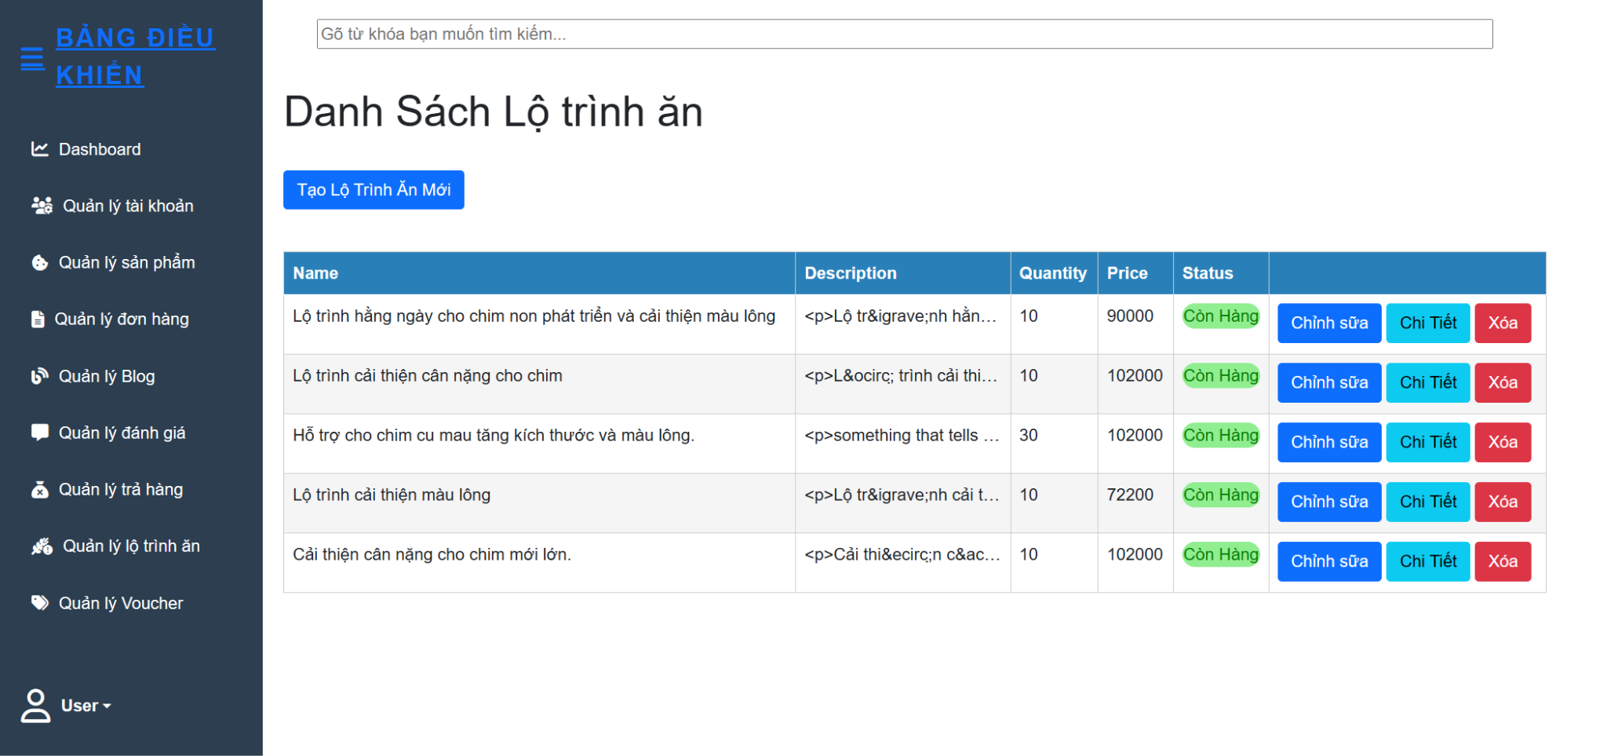

#### b. View Meal Routing Detail

- Function trigger: When staff click on “Detail” in the table of routing manager

- Function description: Staff can view detail of meal

- Function details: Render a screen below, allow staff to see product lists

- Screen layout:

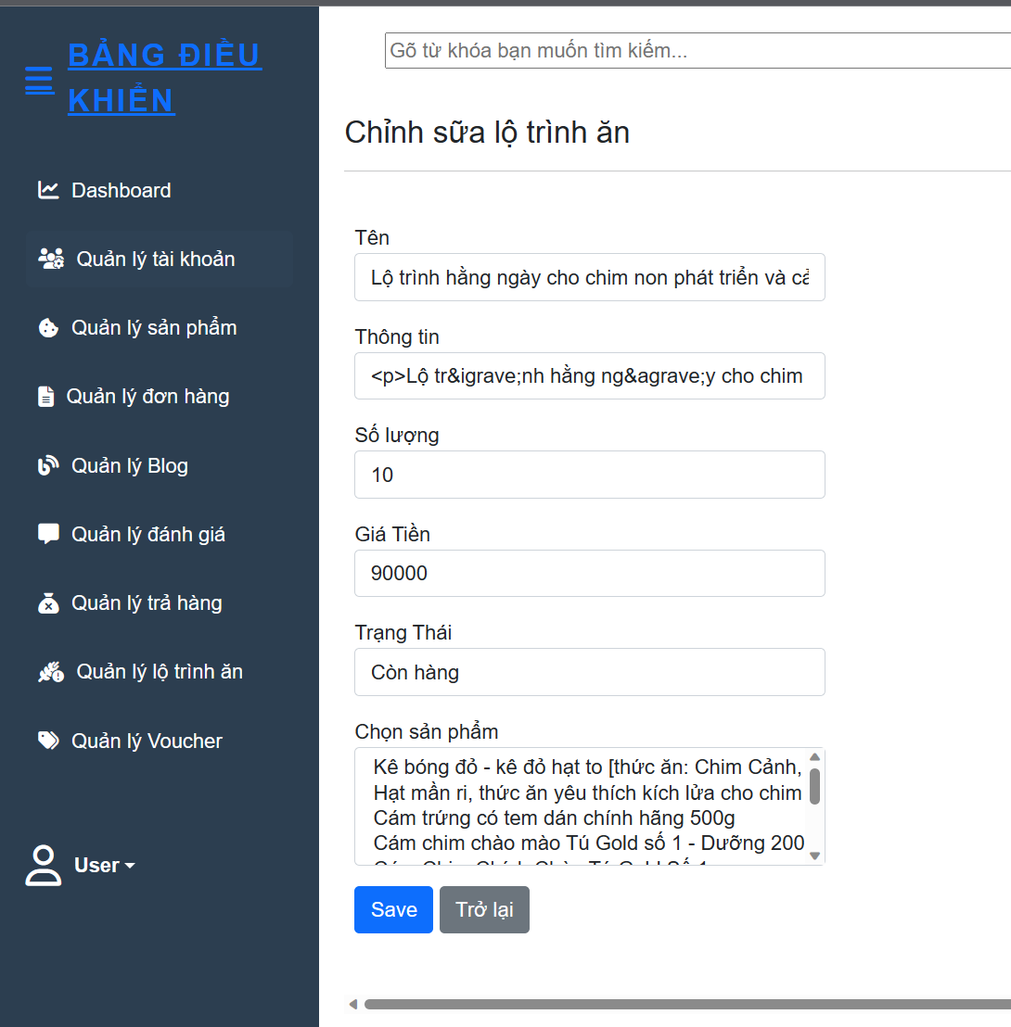

#### d. Add New Meal Routing

- Function trigger: This function is triggered when a staff member clicks the "Add" button on the Routing Management page.

- Function description: The purpose of this function is to allow staff to add new product routings, including a name, details, and a list of products.

- Function details: When a staff member navigates to the Routing Management page and clicks the "Add" button, a form will be displayed for them to fill in the information for the new product routing. Once the staff member has entered the necessary details, they can click the "save" button. The information, including the name, ID, and product list, will be saved in the database. If the process is successful, a new product routing will be added to the system.

- Screen layout: 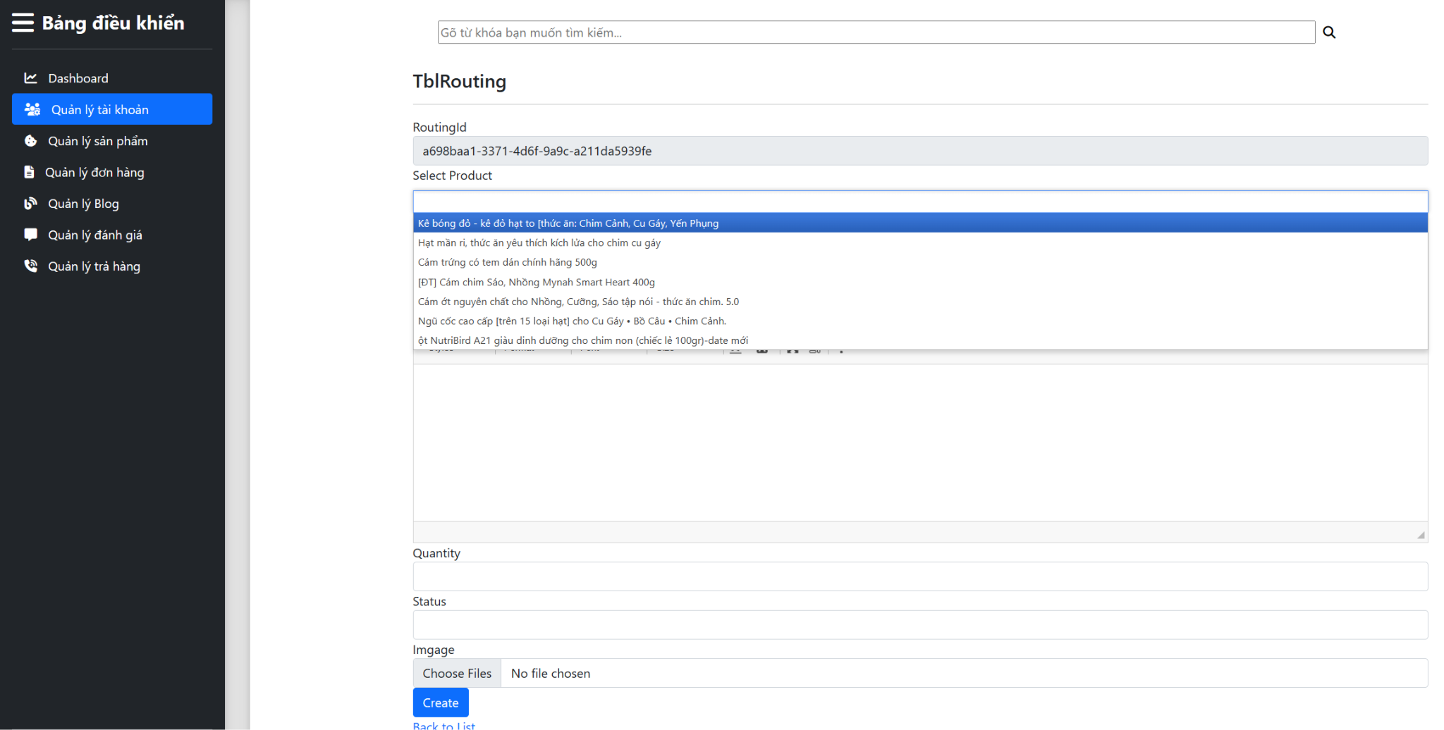

#### 

#### e. Edit Meal Routing

- Function trigger: When staff clicks the “Edit” button in the Routing Management page.

- Function description: This function allows Staff edit information including name, price, id of the previously added meal routing.

- Function details: Edit Meal Routing starts when the staff go to the management page and select the Routing Management. The system will load the data on the database and a list of meal routing has been added. Here, Staff will click the Edit button at the Meal Routing you want to edit, a detailed information form of the selected Meal Routing will appear, Staff will enter the information to be edited in the form and then click "Edit" to complete. The modified meal routing information is updated on the database and reloaded.

- Screen layout: 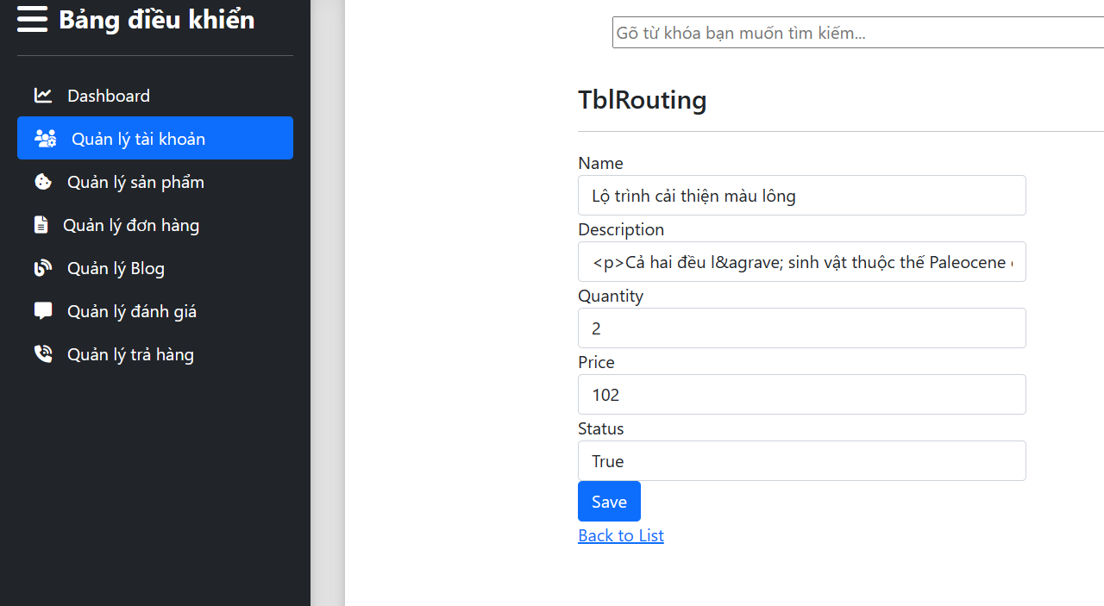

#### f. Remove Meal Routing

- Function trigger: When staff clicks the “Remove” button in the Routing Management page.

- Function description: This function allows Staff remove meal routing.

- Function details: Remove Meal Routing starts when the Staff go to the management page and select the Routing Management. The system will load the data on the database and a list of meal routing has been added. Here, Staff will click the "Remove" button at the Meal Routing they want to remove. The system will delete the data of Meal Routing on the database and reload the Routing Management page.

- Screen layout:

### 3. Manage Order

#### a. View Order List

- Function trigger: When staff click on “Quản lý đơn hàng” in the Management Page.

- Function description: Show the list of order in the system.

- Function details: Show the screen below, for staff can view all orders and can view order details of each account. Therefore, staff can report revenue for the manager.

- Screen layout:

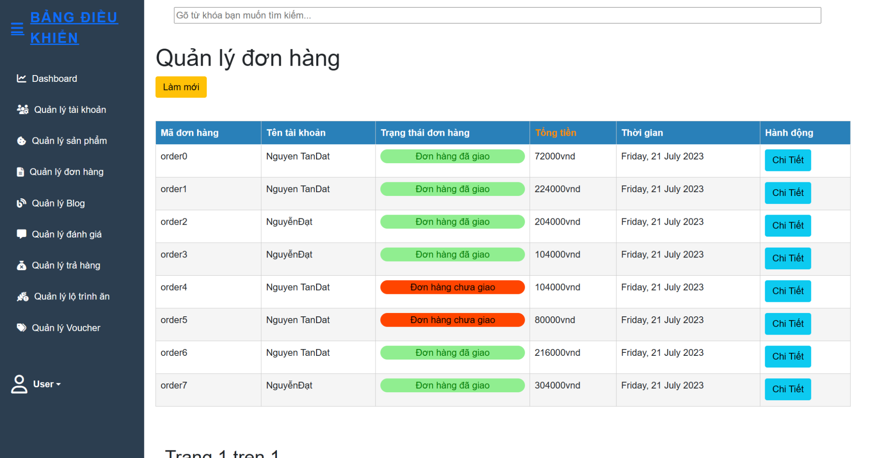

#### b. View Order Detail

- Function trigger: When staff click on the “Chi tiết” button in the “Quản lý đơn hàng”.

- Function description: Pop up the order detail of each order.

- Function details: Show the screen below, for staff to view order details. Therefore, can use tools for scan which products are selling well.

- Screen layout: 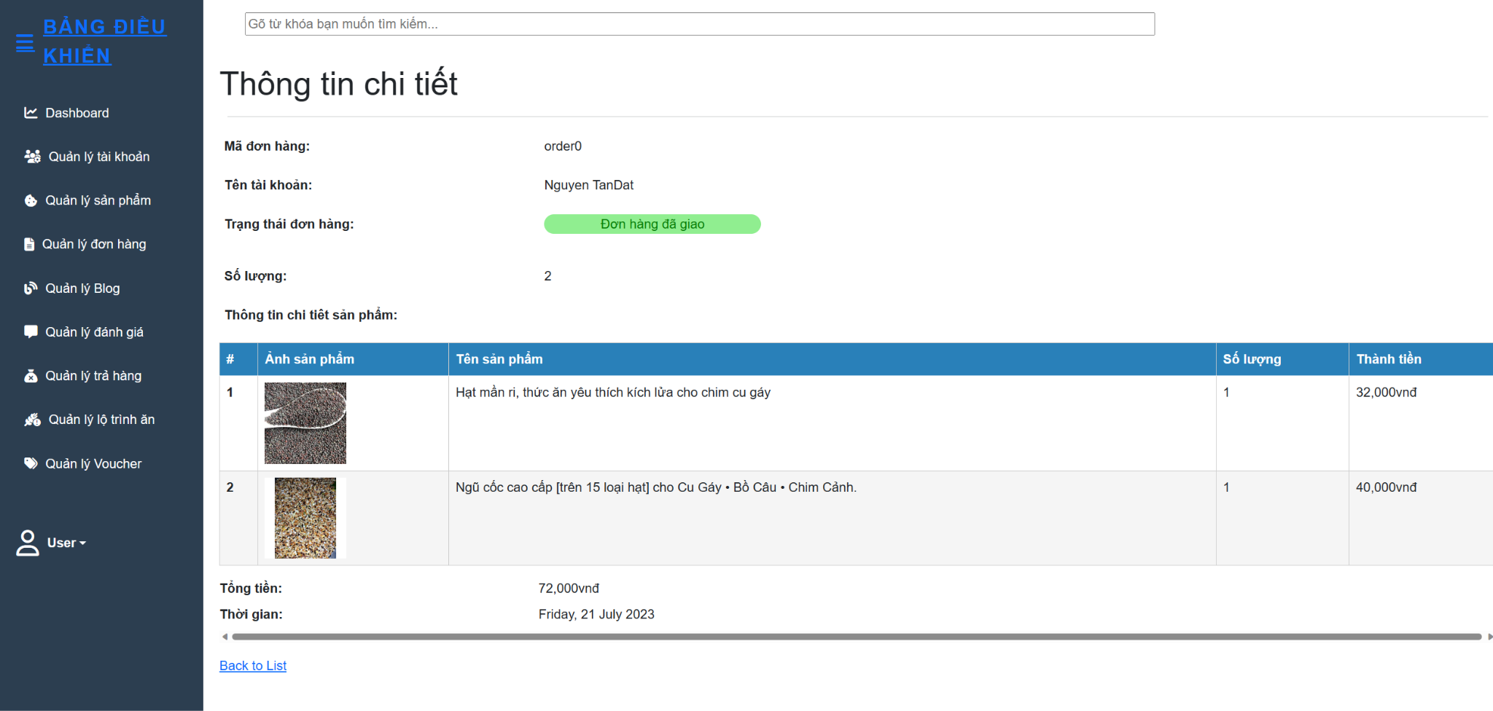

### 4. Manage Blog

- Function trigger: When staff click on “Management Blog” in the sidebar of the Management Page.

- Function description: Display all blogs of the system into a table.

- Function details: Show the screen below for staff can manage all blogs, staff can create, edit or disable a blog from our website.

- Screen layout: 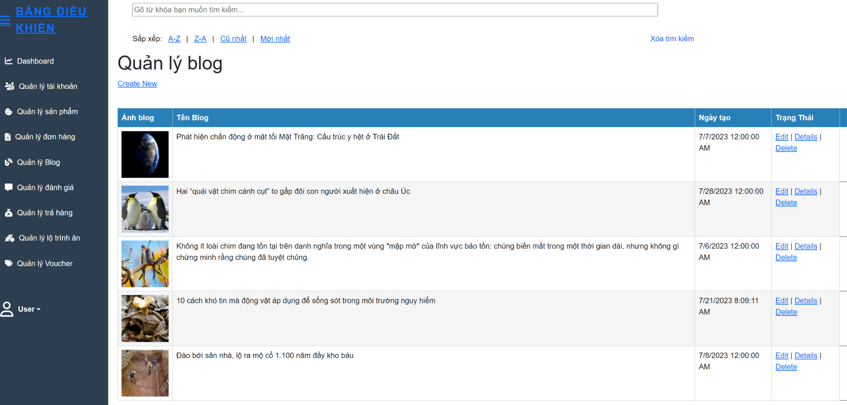

#### a.Add Blog

- Function trigger: When staff click on the “Add blog” button in the sidebar of the Management Page.

- Function description: Have a form for staff asked to fill in information for a blog .

- Function details: The website pops up a form for staff to fill blog title, blog content and add blog images. When staff click on the “Add” button of a form the system will record that blog.

- Screen layout: 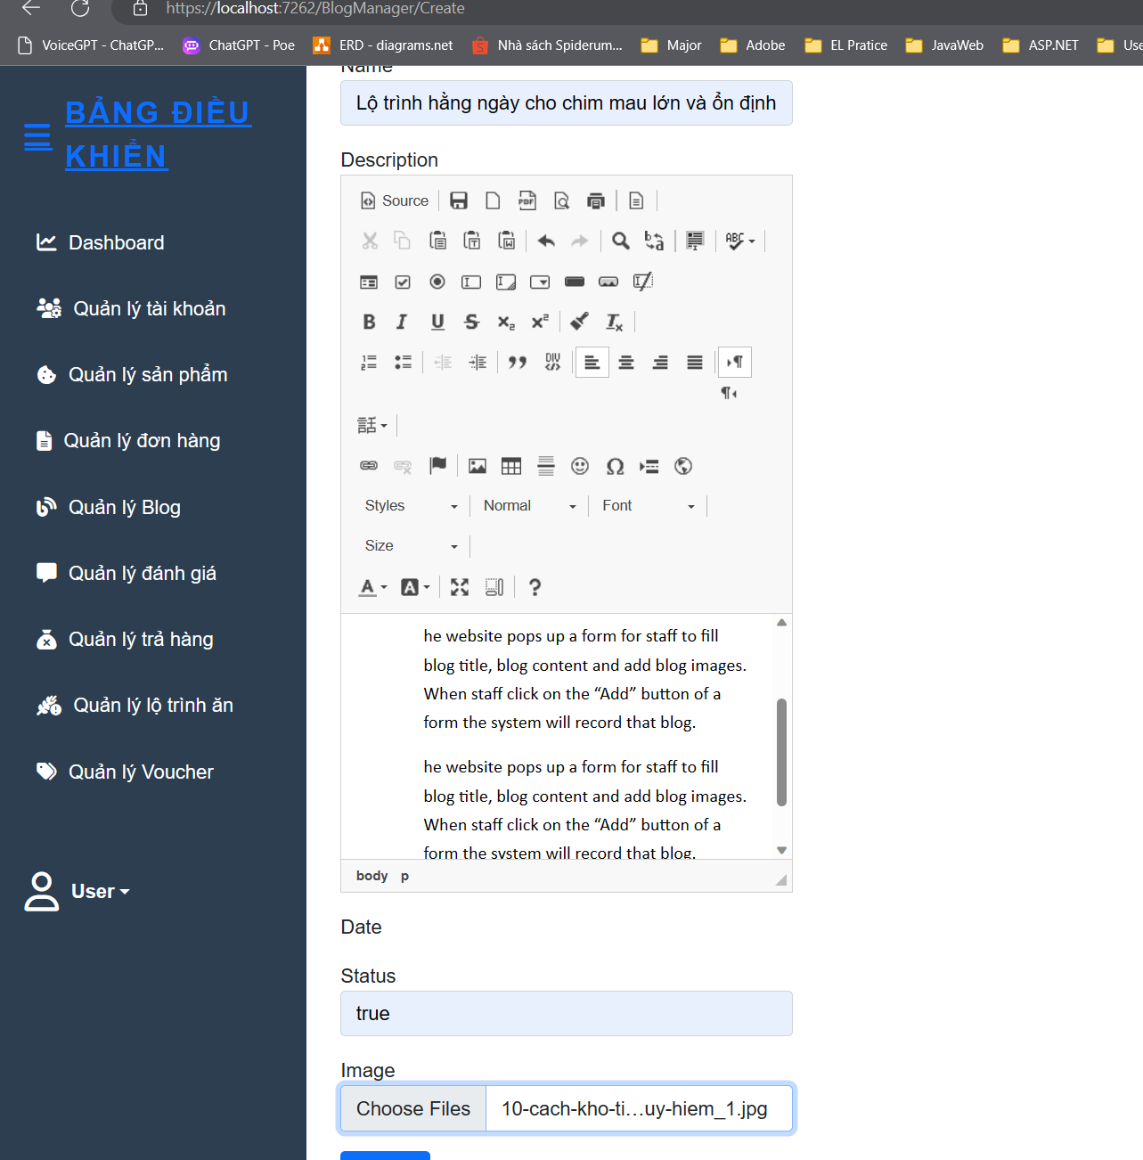

#### b.Edit Blog

- Function trigger: When staff click on the “Edit” button in the action column.

- Function description: Have a form with blog’s information and staff can change it.

- Function details: The website pops up a form. Staff are enabled to edit blog titles, blog content and add blog images in an input form. When staff click on the “Update” button of a form the system will record that blog.

- Screen layout: 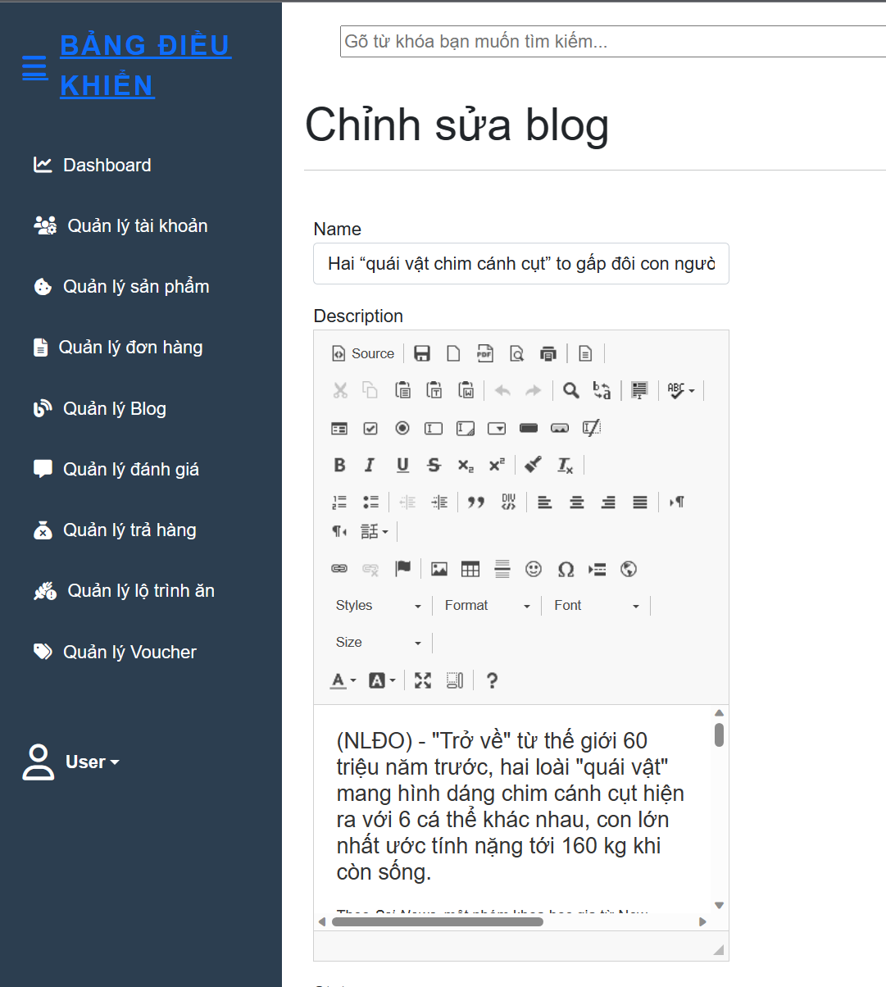

### 5. Manage Feedback

#### a. View Feedback List

- Function trigger: When staff click on “Quản lý đánh giá” in the sidebar of the Management Page.

- Function description: Show the list of feedback of each product.

- Function details: Render the screen below, have name product, start, and feedback content for staff can accept them push in product details to avoid feedback unstable such as spam or danger url.

- Screen layout: 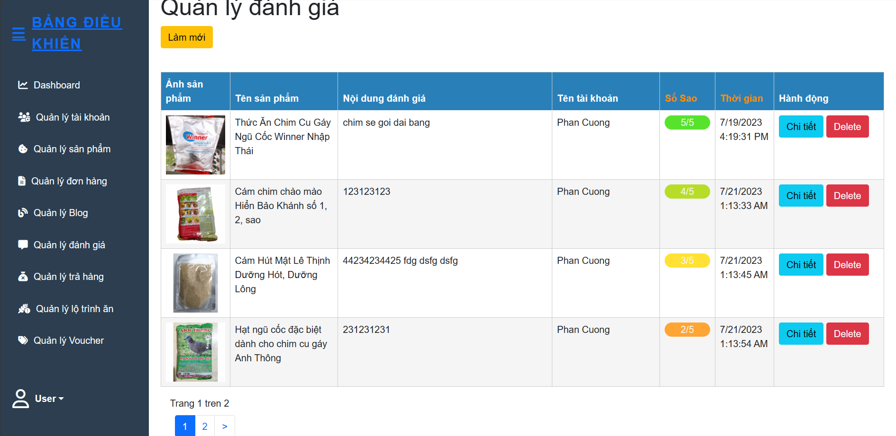

#### b. View Feedback Detail

- Function trigger: When staff click on the “Chi tiết” button in the “Quản lý đánh giá”.

- Function description: Pop up the feedback detail of each feedback.

- Function details: Show the screen below, for staff to view feedback details. Therefore, I can use tools for scan which products is hot selling well.

- Screen layout:

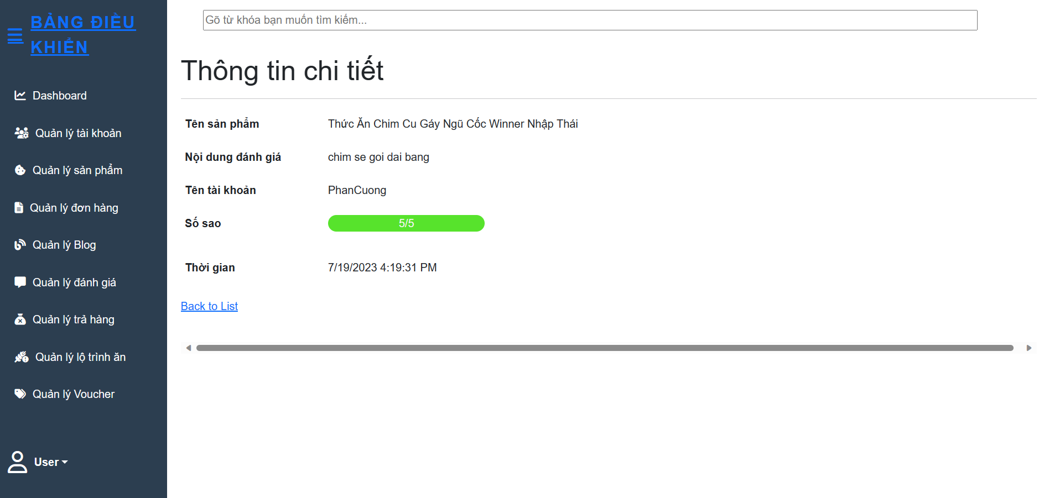

#### c. Delete Feedback

- Function trigger: When staff click on the “Xóa” button in the “Quản lý đánh giá”.

- Function description: This function allows Staff to remove feedback.

- Function details: After the employee visits the "Quản lý đánh giá" page and selects which review he wants to delete and clicks "Xóa", the system will delete that response in the data.

- Screen layout:

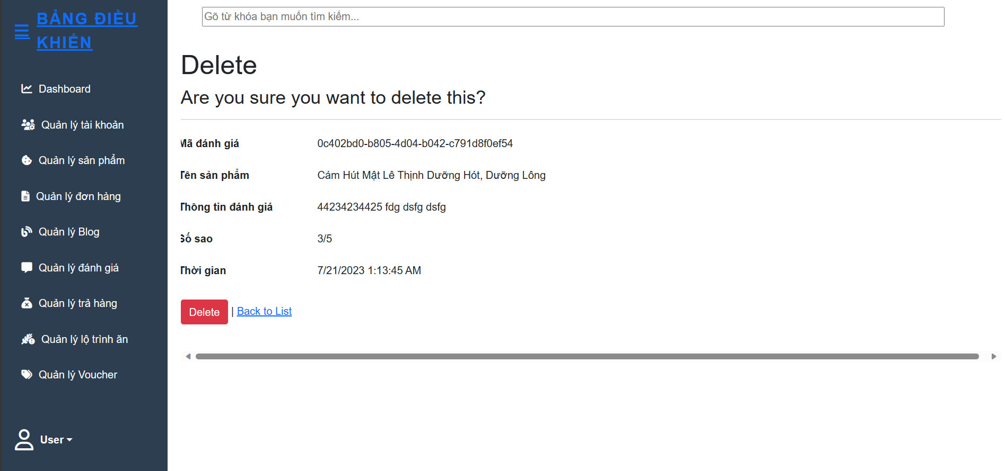

### 6. Manage Refund

**a. View Refund List**

- Function trigger: When staff click on “Refund Management” in the sidebar of the Management Page.

- Function description: Show all refund customer orders.

- Function details:When the staff clicks on “Quản lý hoàn trả” it will display a list of refund orders and can accept or reject the refund order.

- Screen layout:

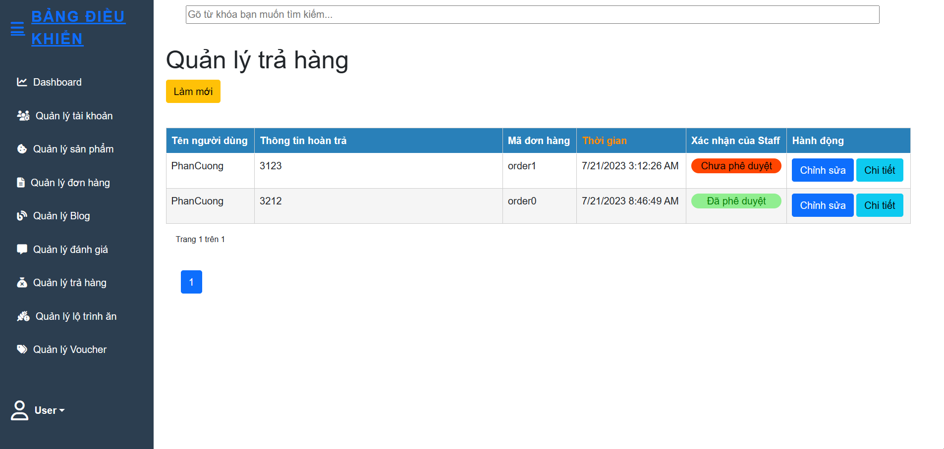

**b. Edit Refund**

- Function trigger: When staff click on the “Chi tiết” button in the “Quản lý hoàn trả”.

- Function description: Show all refund customer orders.

- Function details:When the staff clicks on “Quản lý hoàn trả” it will display a list of refund orders and can accept or reject the refund order.

- Screen layout:

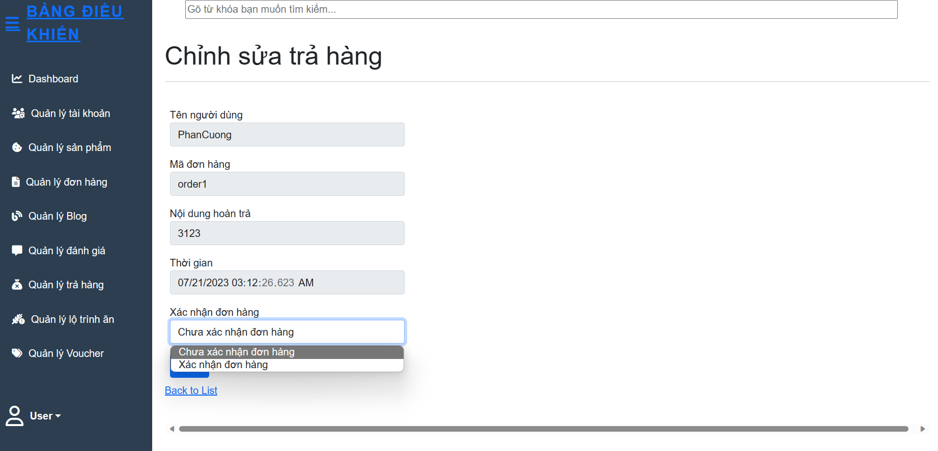

#### C. View Refund Detail

- Function trigger: When staff click on the “Chi tiết” button in the “Quản lý hoàn trả”.

- Function description: Pop up the refund details of each refund.

- Function details: Show the screen below, for staff to view refund details. Therefore, I can use tools for scan which products is hot selling well.

- Screen layout:

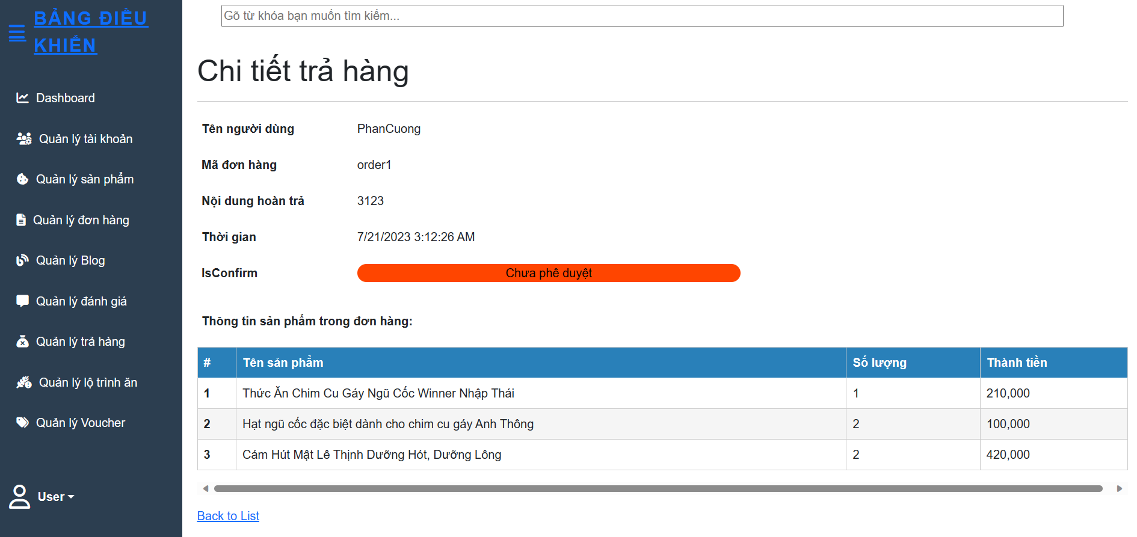

## *Customer Feature

### 1. Cart

#### a. Add Product To Cart

- Function trigger: When a customer clicks “Add to cart” in product detail or in the Home page.

- Function description: This function allows users to add the products they want to buy to the cart so they can proceed to checkout later.

- Function details: When the user clicks on the “Add to cart” button, the product will be added to the cart and the product's information will be stored in the user's cart. Users can continue to add other products or view their shopping cart to check and edit before checkout.

- Screen layout:

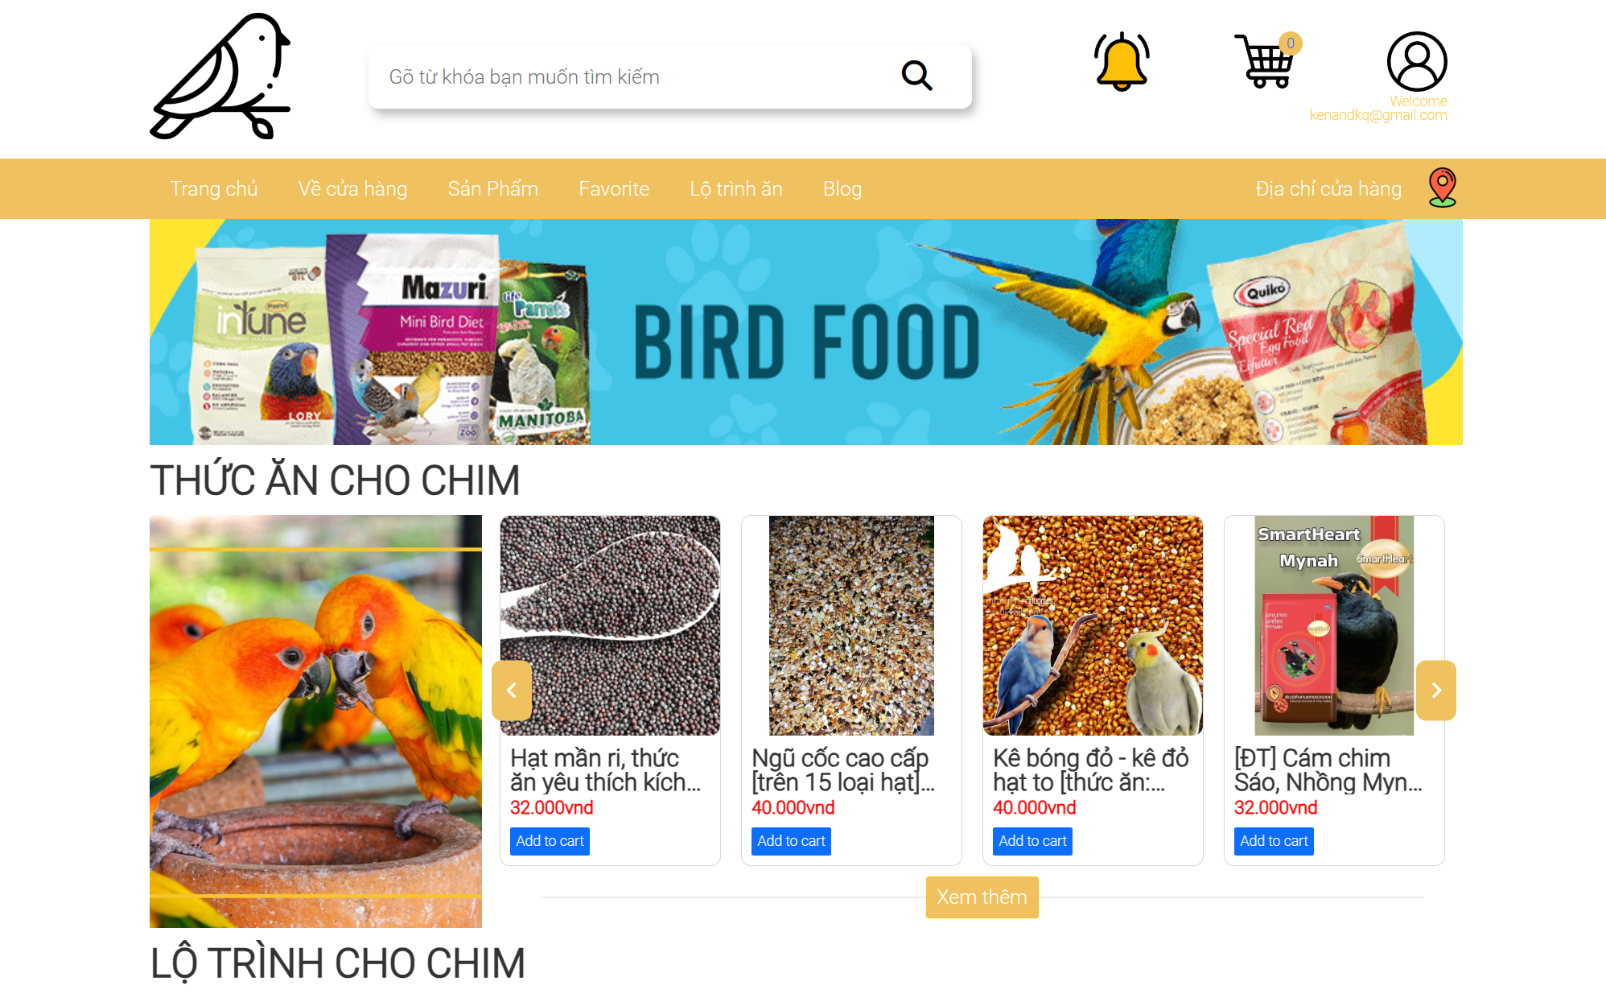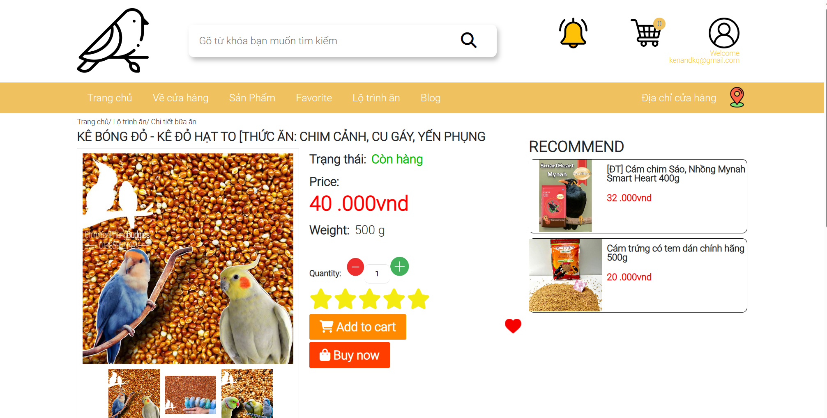

#### b. Edit Product In Cart

- Function trigger: User click on “icon cart” in the header and sendirect to cart detail.

- Function description: Users can edit the quantity of product or remove them out of cart.

- Function details: To be able to edit the products added to the cart, the user can click on the cart icon on the header, the "Product detail" page will appear on the screen. At this page, users can increase or decrease the quantity of previously added products or users can click the "Remove to cart" button to remove the products added to the cart.

- Screen layout:

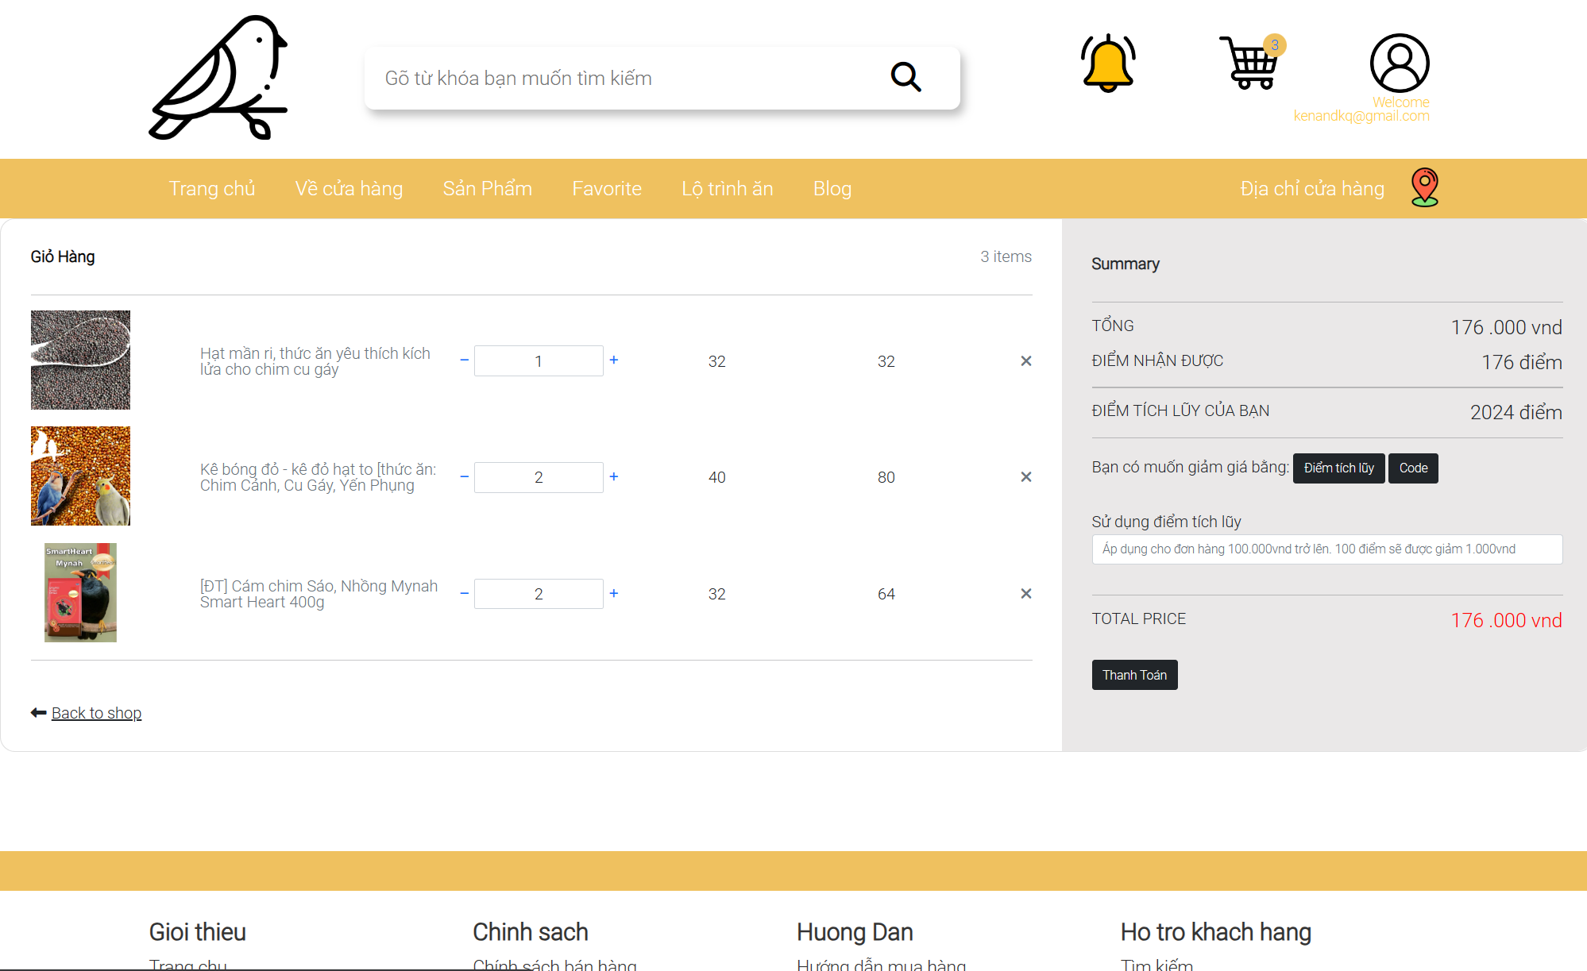

#### c. Cart Detail

- Function trigger: Customer clicks on the cart icon in the header.

- Function description: Allows customers to see how many products are in their cart and they can edit it if they want.

- Function details: Start when customers want to see what is inside their cart and they click on the button to check it.

- Screen layout:



#### d. Use Point And Voucher

- Function trigger: Customer clicks on “Điểm tích lũy” in the cart detail page. Then type point or code voucher in the input.

- Function description: System will validate the point or code voucher, then discount the total price based on the value of that point or code voucher.

- Function details: Customer type code or point in to the input in the right of cart detail. Then the system will notify them to know which code or point they type is valid or not.

- Screen layout:

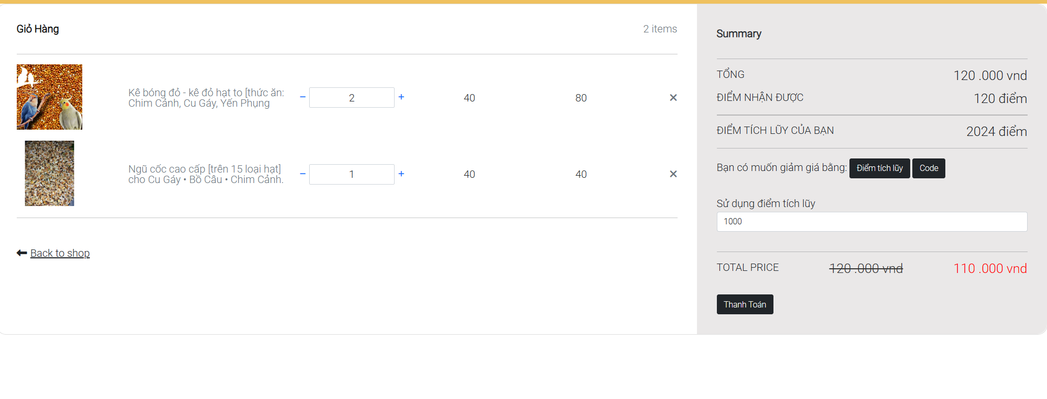

### 2. Feedback

#### a. Add Product To Favourite List

- Function trigger: When a customer clicks on “Add product to favourite list” button in product item.

- Function description: Add a product to the favourite list when the customer wants.

- Function details: Render the screen below, at a product item will display a screen with a list that has a product that is selected will occur in the list of favourite products when a customer clicks on the “add product to favourite list”.

- Screen layout:

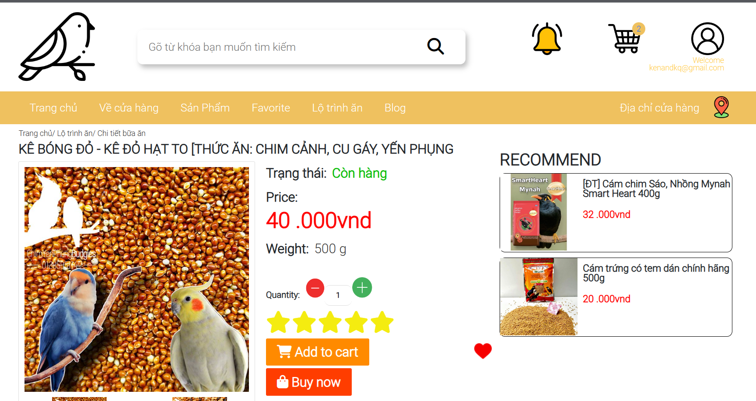

#### b. View Product In Favourite List

- Function trigger: When a customer clicks on the “Favourite list in the navigation” in a product item from their favourite products list.

- Function description: Render list of favourite list

- Function details: Render the screen below, at a favourite products list will display a screen.

- Screen layout:

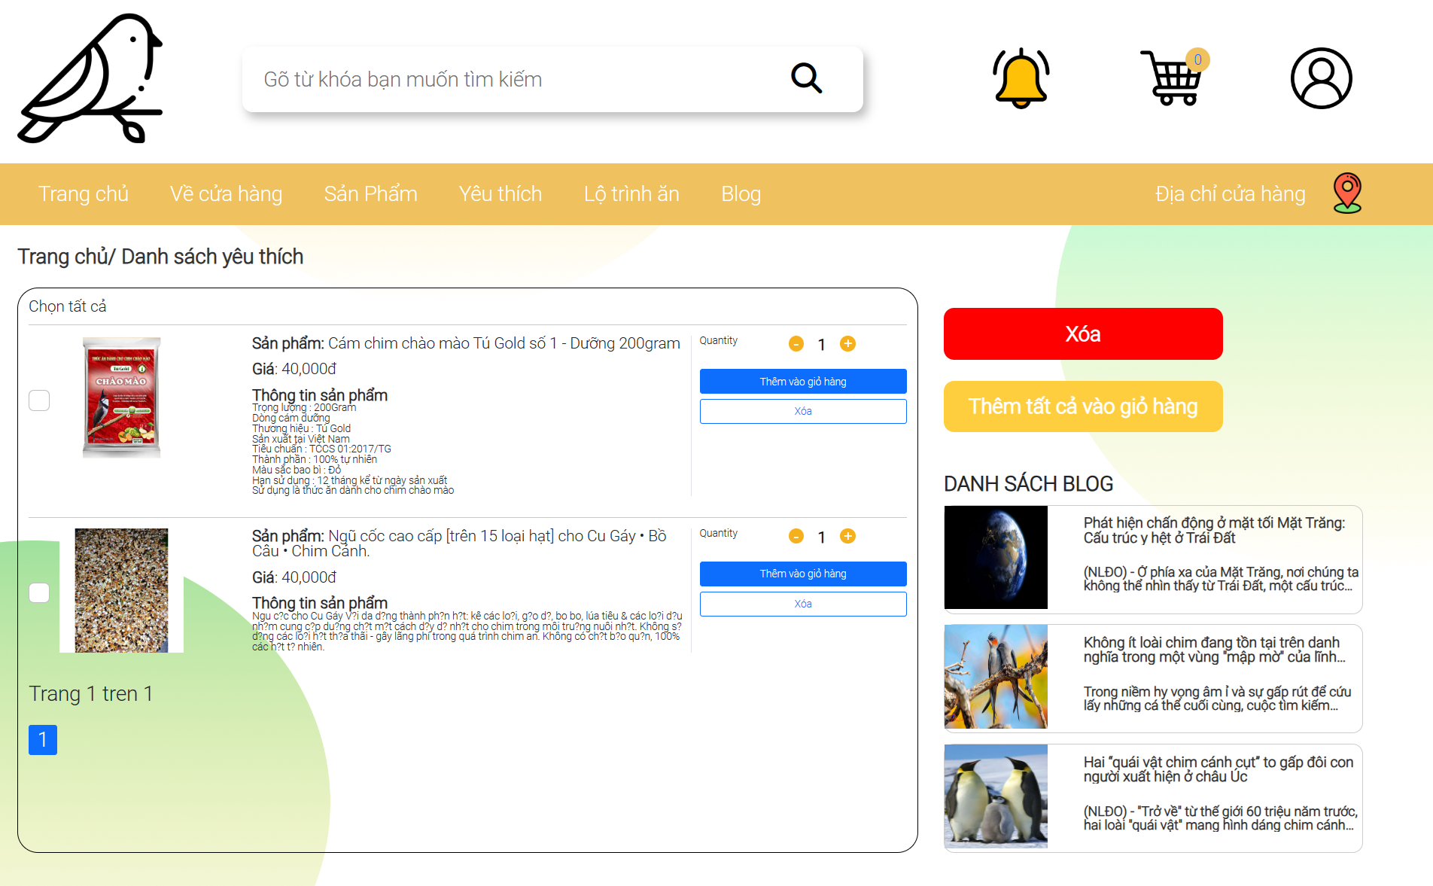

#### c. Remove Product From Favourite List

- Function trigger: When a customer clicks on the “remove” button in a product item from their favourite products list.

- Function description: Remove a product from the favourite products list.

- Function details: Render the screen below, at a favourite products list will display a screen, with a list that has a product that is selected to remove out from the favourite products list will disappear when a customer clicks on the “add product to favourite list”.

- Screen layout:

#### d. Rating Product

- Function trigger: when user clicks on start in product item or in product detail.

- Function description: Users can rate 1 to 5 stars in a product, to show how satisfied their requirement.

- Function details: render a screen below, for users to rate our product.

- Screen layout:

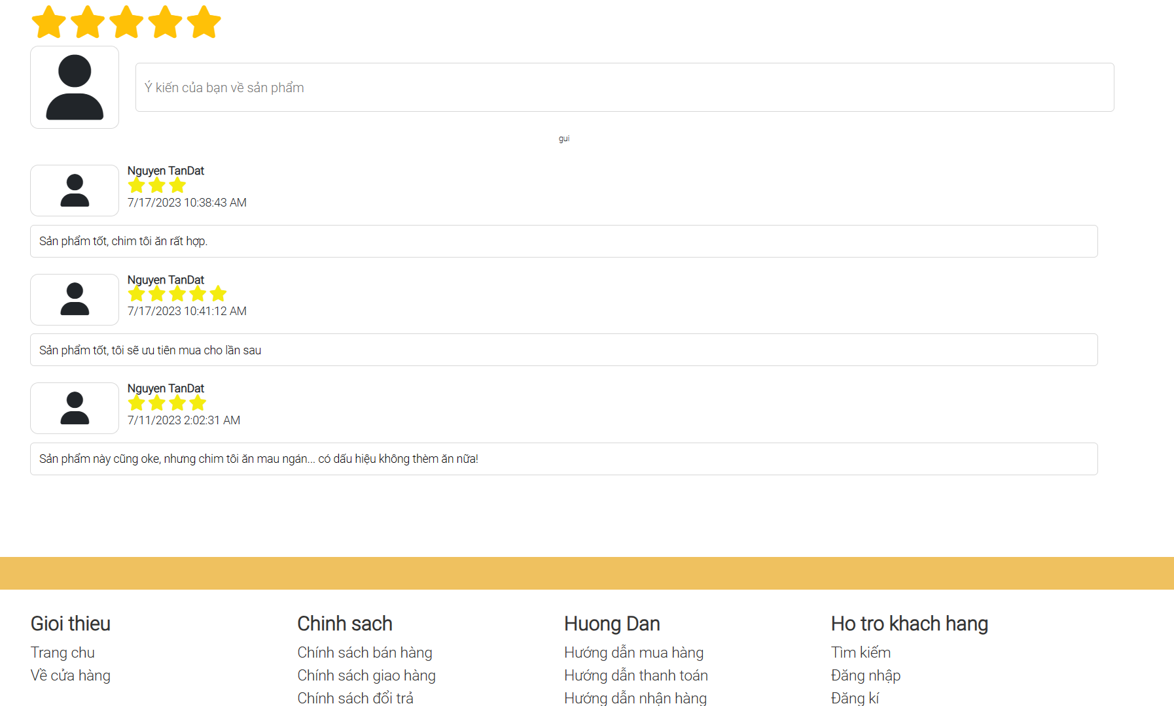

#### e. View Feedback

- Function trigger: When a user clicks on a product item to see product detail.

- Function description: Feedback of other users will render in the feedback content.

- Function details: Render a screen below, where to show feedback of this product.

- Screen layout:



#### f. Send Feedback

- Function trigger: In product detail users can type their feedback on this product.

- Function description: have an input text in the below of product detail for users to type their feedback.

- Function details: Render a screen below, for users to type their feedback.

- Screen layout:



### 3. Checkout

- Function trigger: When the user clicks on “checkout button” in cart detail.

- Function description: Sendirect them to the check out page.

- Function details: Display a screen below, for customers to fill in the info such as their phone and their location to receive the product.

- Screen layout: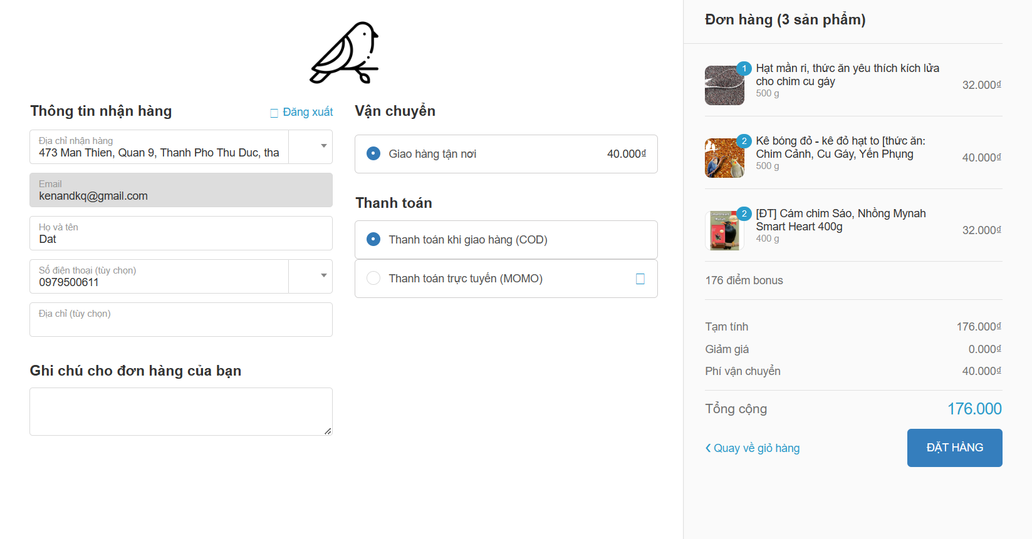

### 4. Contact

- Function trigger: when user clicks on contact icon in the bellow of screen.

- Function description: Users can contact staff on the contact page.

- Function details: Render a screen below, for type their message and send it to Contact Management.

- Screen layout: 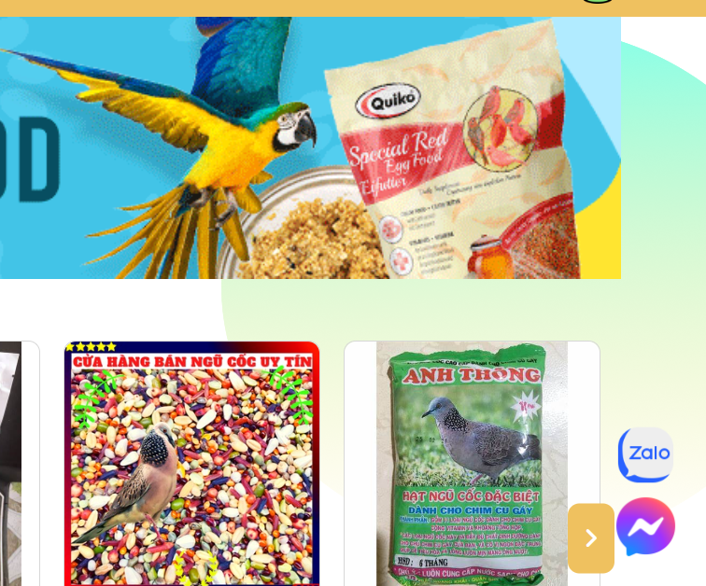

### 5. Get Point Bonus

- Function trigger: When a customer finishes a purchase for a product, a screen will display.

- Function description: This function helps customers to gain points when they buy a product and they can use it for later purchase.

- Function details: Render a screen below to see how much points gain when customers buy a product.

- Screen layout:

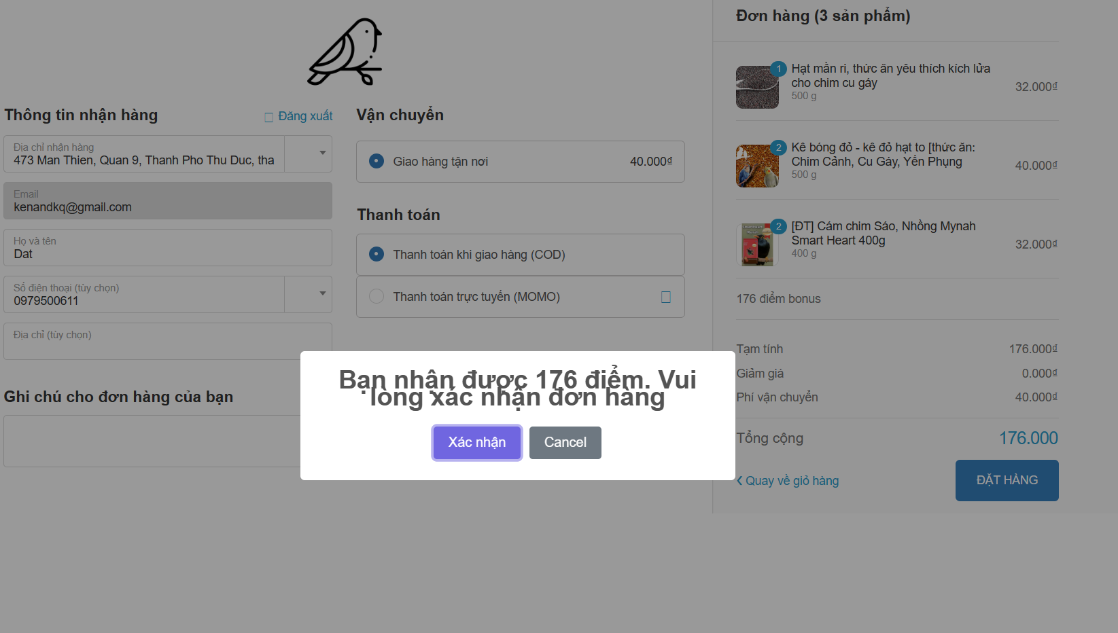

### 6. User Profile

#### a. Add User Location

- Function trigger: This function triggers when a customer clicks the "Thêm địa chỉ" button in the "Cài đặt địa chỉ" section of the User Profile page.

- Function description: User can create his/her location information for delivery service.

- Function details: Display the below screen.

.- Screen layout:

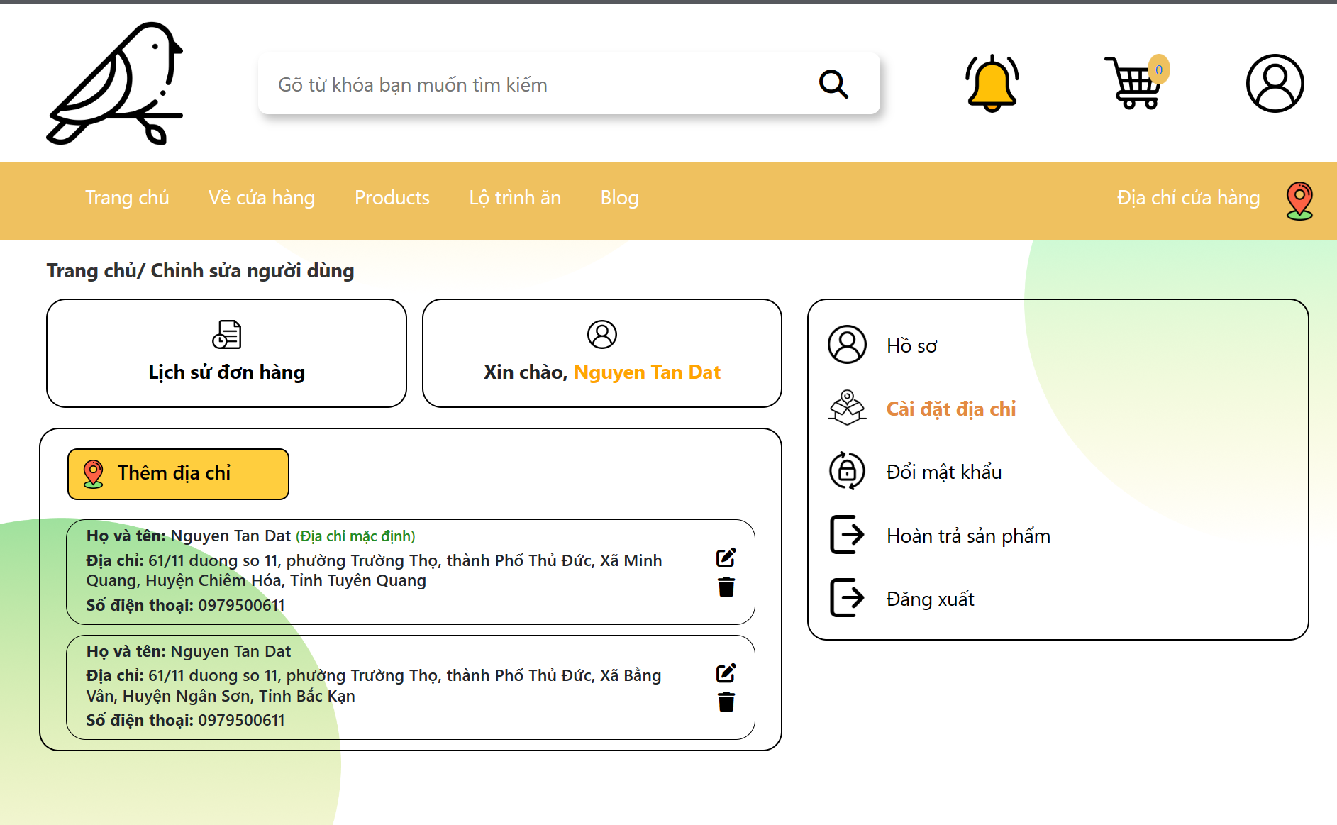

#### b. Edit User Location

- Function trigger: This function triggers when a customer clicks the "Chỉnh sửa" button in the "Cài đặt địa chỉ" section of the User Profile page.

- Function description: User can update his/her location information for delivery service.

- Function details: display a below screen, similar edit user profile function but edited data is registered user address.

.- Screen layout:

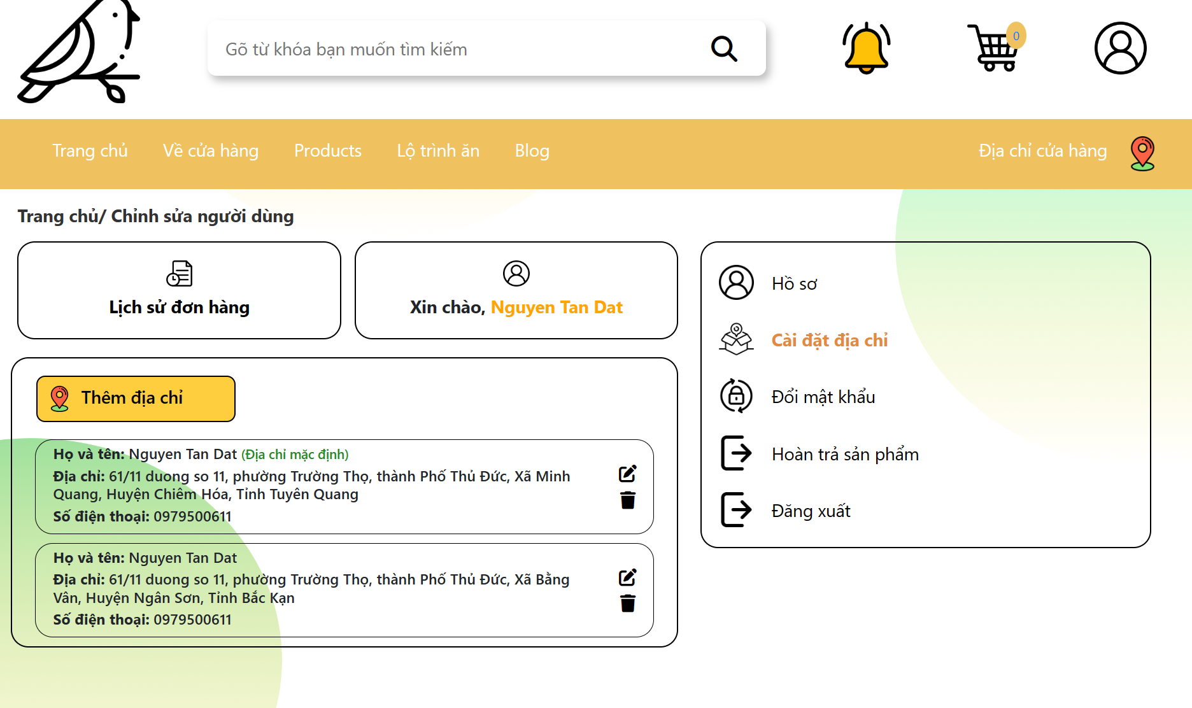

#### c. View Order History

- Function trigger: This function triggers when a customer clicks the "Lịch sử đơn hàng" button in the User Profile page.

- Function description: Users can view all orders bought before.

- Function details: Display the below screen.

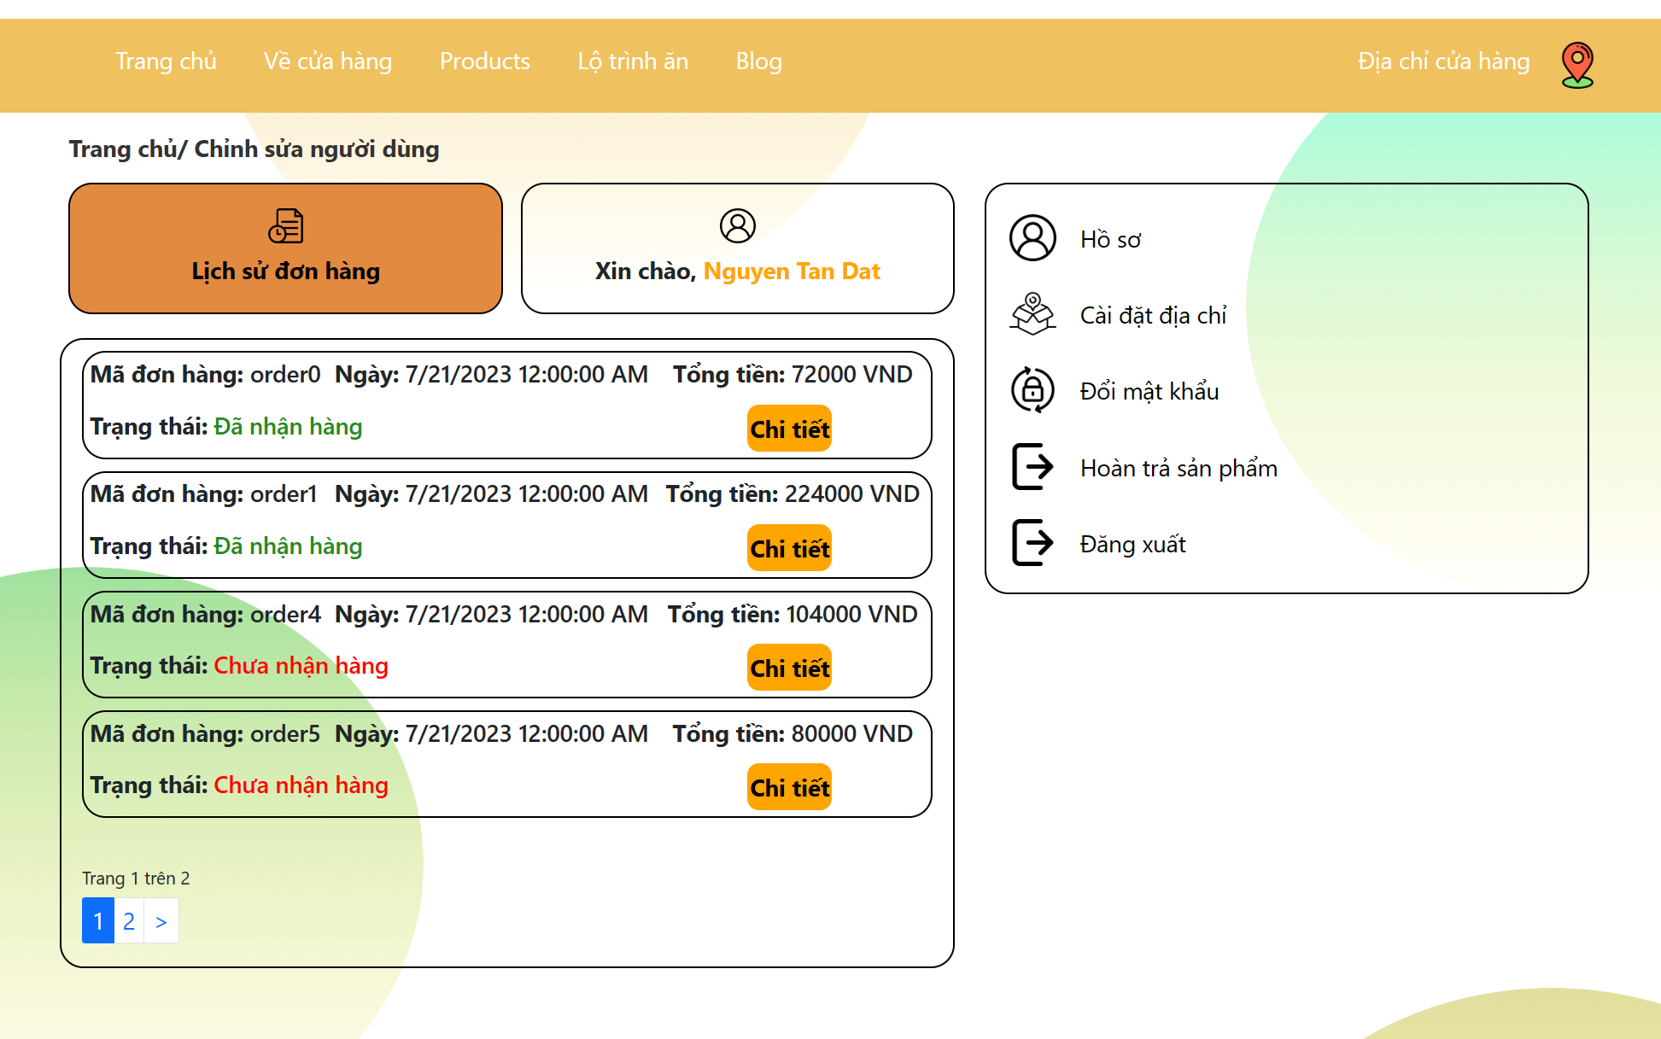

- Screen layout:

#### d. Refund Order

- Function trigger:When the user clicks on the “Hoàn trả” button in History Order Detail.

- Function description: This function helps users to return products, get money back at the store when the product is faulty or has problems.

- Function details: At the History Order Detail Page, the user clicks the “Hoàn trả” button on the screen. The system will display a form including the customer's name, contact information, the ID of the product you want to return and the reason. The user will fill in the information in this form, then press the "Submit" button. This form will be sent to the Manage Refund page managed by Staff. Staff will check and review the user's request.

- Screen layout:

